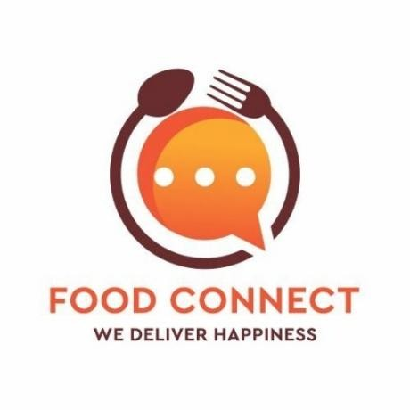

**To supply leftover food to poor**



Velagaracharla Varshitha

22701A05M4

[varshi9182@gmail.com](mailto:varshi9182@gmail.com)

AITS, Rajampet

**Project Overview:**

This CRM enables efficient redistribution of surplus food from donors—such as restaurants, events, and households—to recipients—like charities, shelters, and volunteers—through a unified platform. Donors can quickly submit listings with details like type, quantity, expiry, and pickup window. The system then leverages geo-location matching and real-time notifications to streamline scheduling, routing, pickup tracking, and compliance. Impact tracking (e.g., meals rescued, volunteer hours, CO₂ saved) and robust communication tools ensure transparency, efficiency, and safety across operations.

**Key features include:**

* **Donor & Recipient Management**: Enable registration and detailed profiles for donors (with donation history) and recipients/volunteers for effective matching and communication.
* **Food Listings with Real-Time Notifications**: Post surplus items quickly; notify stakeholders instantly.
* **Geo-Matching & Routing**: Auto-match donations to nearby NGOs/volunteers and optimize pickup routes via geolocation APIs.
* **Volunteer Scheduling & Logistics**: Assign pickup tasks, set dates/times, and send reminders—streamlining volunteer coordination.
* **Impact Reporting & Analytics**: Track meals distributed, CO₂ emissions saved, and more.
* **Impact Reporting & Analytic**: Monitor expiry dates and maintain audit trails.
* **Secure, Mobile-Ready Platform:** Accessible anytime, anywhere with robust data protection.

**Business Benefits:**

* **Reduce Food Waste:** Quickly match surplus with need to prevent spoilage**.**
* **Boost Community Engagement:** Reliable system builds trust among donors, NGOs, and volunteers.
* **Improve Efficiency**: Automations free the team to focus on strategy and outreach.
* **Enable Impact Transparency:** Use data to engage stakeholders, secure funding, and report results.
* **Ensure Safety & Compliance**: Maintain records for food safety and organizational accountability.

This CRM system meets critical business needs by addressing food insecurity, reducing food waste, and enhancing the efficiency of charitable food distribution efforts. It helps organizations work more effectively, ensuring that no food goes to waste while supporting those in dire need.

**Objectives:**

The primary goal of building the FOODCONNECT CRM is centralize donor, volunteer, and recipient data to streamline coordination and reduce administrative effort—enhancing operational efficiency. It also aims to automate workflows and notifications for surplus food listings, pickups, and deliveries, minimizing spoilage and maximizing meals rescued. By enabling geolocation-based matching and route planning, it ensures rapid, cost-effective distribution. Additionally, the CRM will track impact metrics (such as meals saved and volunteer hours) to reinforce transparency and bolster stakeholder engagement. Finally, it supports safety and compliance monitoring, giving confidence to partners and preparing the initiative for sustainable growth. These objectives align with key nonprofit CRM outcomes: better relationship management, automated operations, improved volunteer engagement, and impactful reporting**.**

**Phase 1: Requirement Analysis & Planning**

**Understanding Business Requirements:** The key requirement of this project is to establish an organized platform that connects restaurants, hotels, and event organizers willing to donate leftover food with NGOs or volunteer groups who can distribute it to the poor. The system needs to efficiently track food availability, coordinate pickups and deliveries, monitor beneficiary reach, and maintain transparent records. Users require a solution that minimizes manual coordination, prevents food spoilage, and ensures that surplus food is safely and quickly routed to the needy.

**Defining Project Scope and Objectives:**

* Develop a CRM system on Salesforce to register and manage profiles of donors (restaurants, hotels) and recipients (NGOs, shelters, volunteer groups).
* Automate the process of scheduling pickups and assigning delivery tasks based on food type, quantity, and location.
* Maintain historical records of donations and distributions to enable tracking and reporting.
* Implement notifications and reminders for timely pickups, and acknowledgements to donors after successful delivery.
* Generate insightful dashboards to visualize the amount of food saved, number of beneficiaries served, and partner engagement, aiding in promoting the initiative and attracting new donors.

**Design Data Model and Security Model:**

The data model includes custom objects like Donor, Food Donation, Pickup Schedule, Recipient, and Distribution Record, linked through appropriate relationships to maintain a clear trail from donation to delivery. The security model employs profiles and role hierarchies to ensure that restaurant managers, NGO coordinators, and volunteer drivers have access only to the data relevant to their roles. Permission sets and sharing rules are configured to maintain data privacy while supporting collaborative workflows among multiple partners.

**Phase 2: Salesforce Development - Backend & Configurations**

**Setup environment & DevOps workflow:** A dedicated Salesforce sandbox environment was set up for the development and initial testing of the FOODCONNECT CRM. This enabled isolated customization without impacting production data. A simple DevOps process was followed using Change Sets to migrate metadata from the sandbox to production, ensuring controlled deployments and version management.

**Customization of Objects, Fields, Validation Rules, Automation:**

**Create Venue Object**

To create an object:

1. Setup → Object Manager → Create → Custom Object.
2. Name the object “Venue” (singular), plural label “Venues.”
3. Set Record Name as “Venue Name” with Data Type: Text.
4. Enable Allow Reports, Track Field History, Allow Activities, and Allow Search.
5. Click Save.

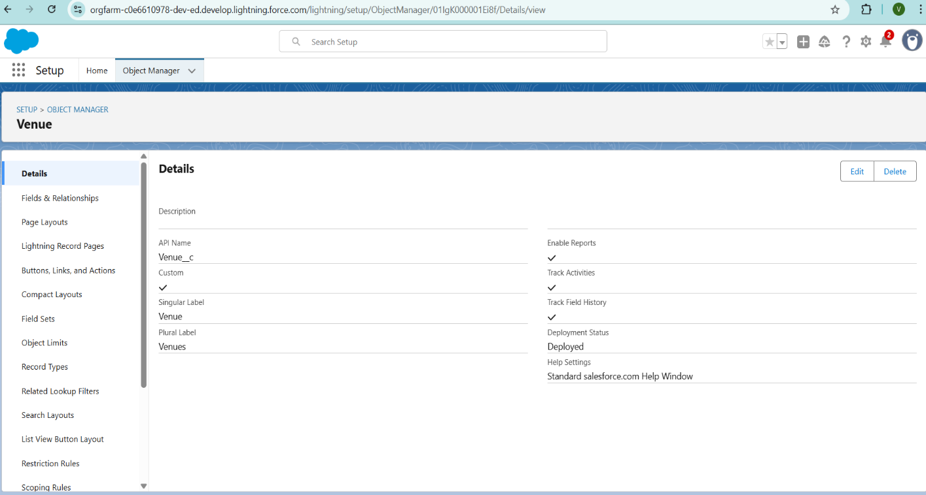

**Create Drop-Off Point Object**

To create an object:

1. Go to **Setup → Object Manager → Create → Custom Object**.
2. Set **Label** = Drop-Off Point, **Plural Label** = Drop-Off Points.
3. Define **Record Name**: Drop-Off Point Name (Data Type = Text).
4. Enable **Allow Reports**, **Track Field History**, **Allow Activities**, and **Allow Search**.
5. Click **Save**.

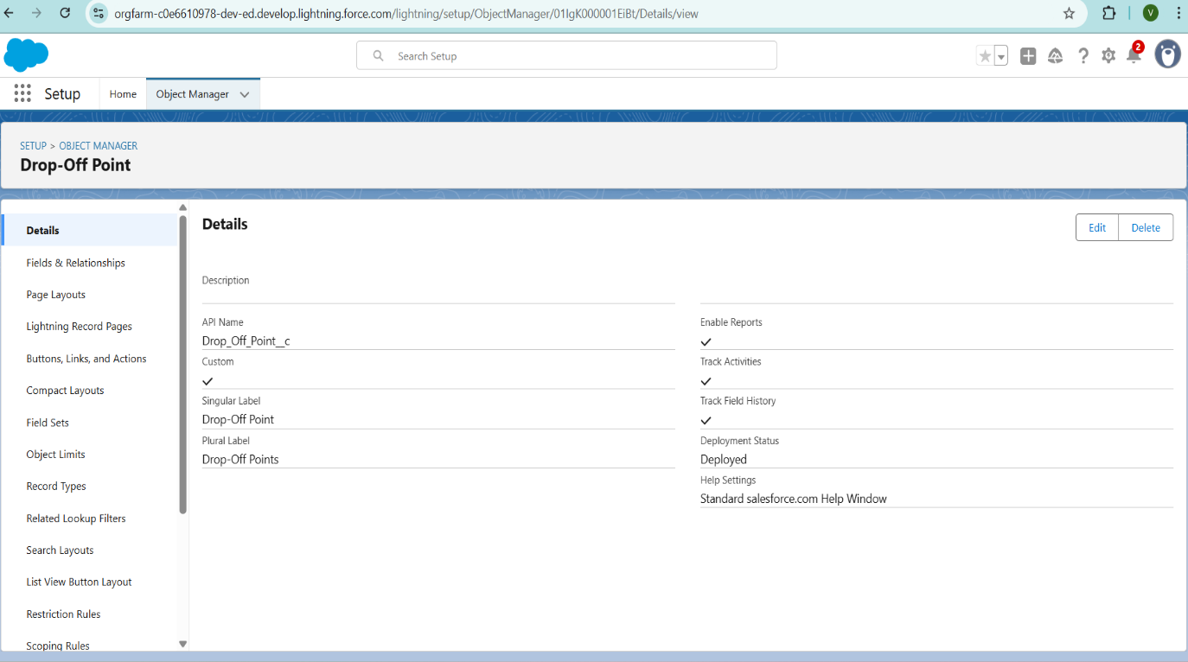

**Create Task Object**

To create an object:

1. Setup → Object Manager → Create → Custom Object.
2. Label: **Task** | Plural Label: **Tasks.**
3. Record Name: **Task Name** (Data Type: Text).
4. Enable **Allow Reports**, **Track Field History**, **Allow Activities**, **Allow Search.**
5. Click **Save.**

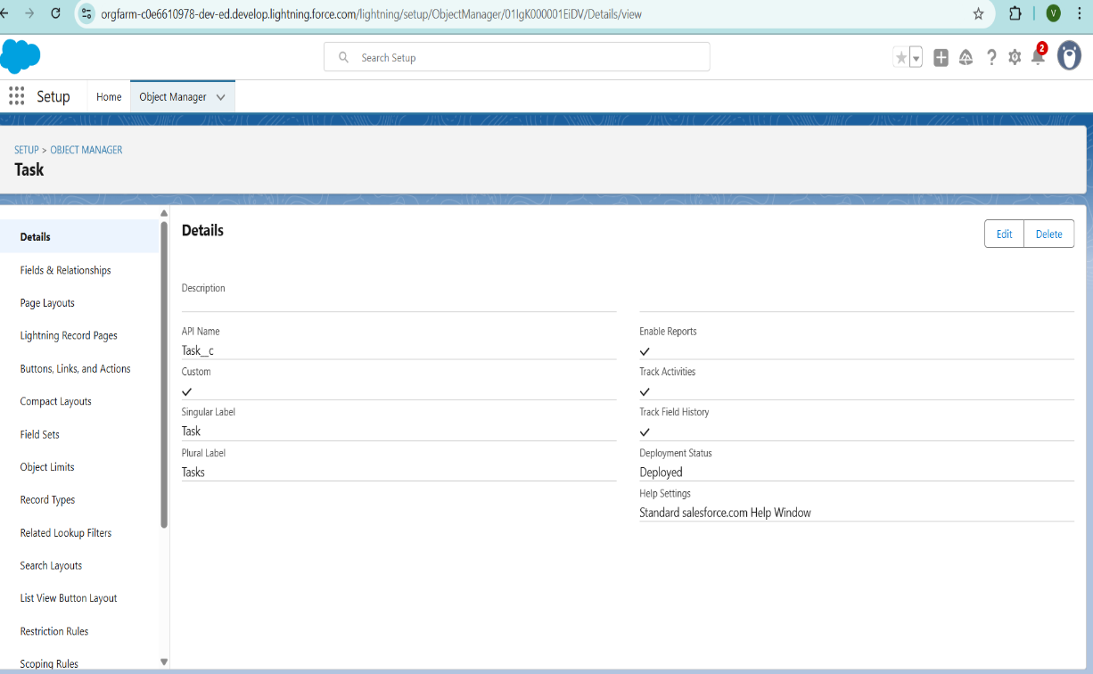

**Create Volunteer Object**

To create an object:

* 1. Setup → Object Manager → Create → Custom Object.
  2. Set: **Label** = Volunteer, **Plural Label** = Volunteers, **Record Name** = Volunteer Name (Text).
  3. Enable: **Allow Reports**, **Track Field History**, **Allow Activities**, **Allow Search.**
  4. Hit **Save.**

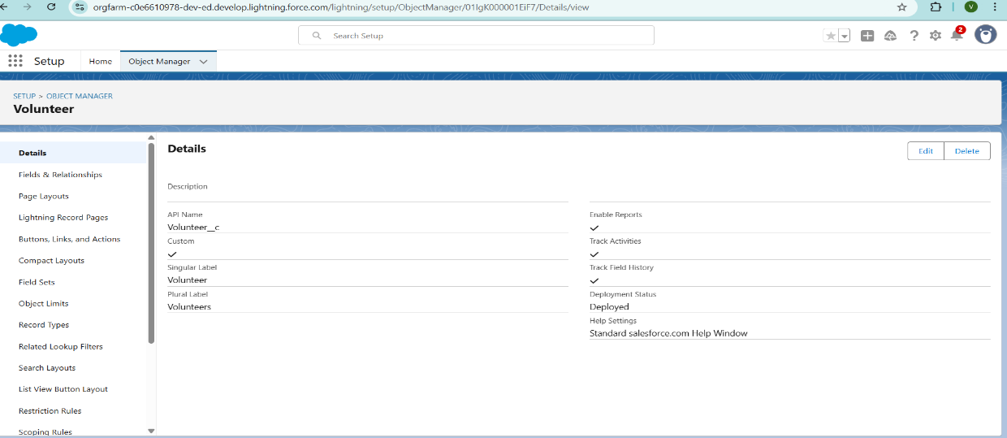

**Create Execution Details Object**

To create an object:

1. Setup → Object Manager → Create → Custom Object.
2. Set: **Label** = Execution Detail, **Plural Label** = Execution Details, **Record Name** = Execution Detail Name (Text).
3. Enable **Allow Reports**, **Track Field History**, **Allow Activities**, **Allow Search.**
4. Hit **Save.**

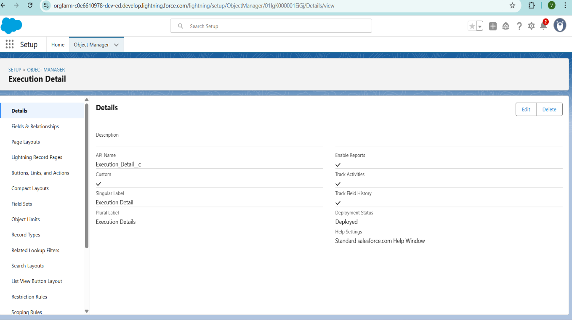

**Creation of Relationship fields in objects**

Creation of Lookup Relationship Field on Volunteer Object:

1. Setup → Object Manager → Volunteer → Fields & Relationships → New.
2. Choose **Master-Detail Relationship**, click **Next.**
3. Select **Drop-Off Point**, click **Next.**
4. Field Name: **Drop_off_point** (Label auto-generated) → Click **Next** twice → **Save.**

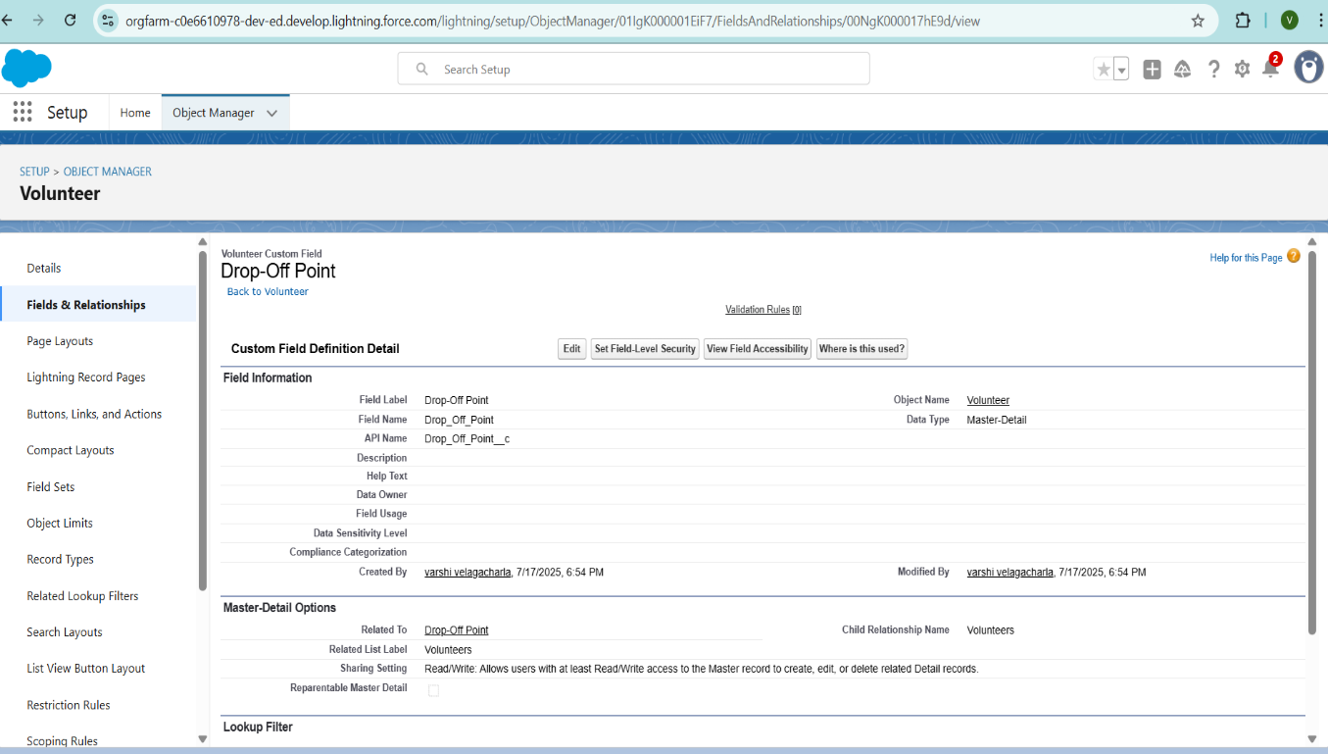

**Creation of Master Detail Relationship Field on Execution Details Object**:

1. Setup → Object Manager → Execution Details → Fields & Relationships → New.
2. Select **Master-Detail Relationship**, click **Next.**
3. Choose **Volunteer**, click **Next.**
4. Field Name: **Volunteer** (Label auto-generated) → click **Next** twice → **Save.**
5. **Save.**

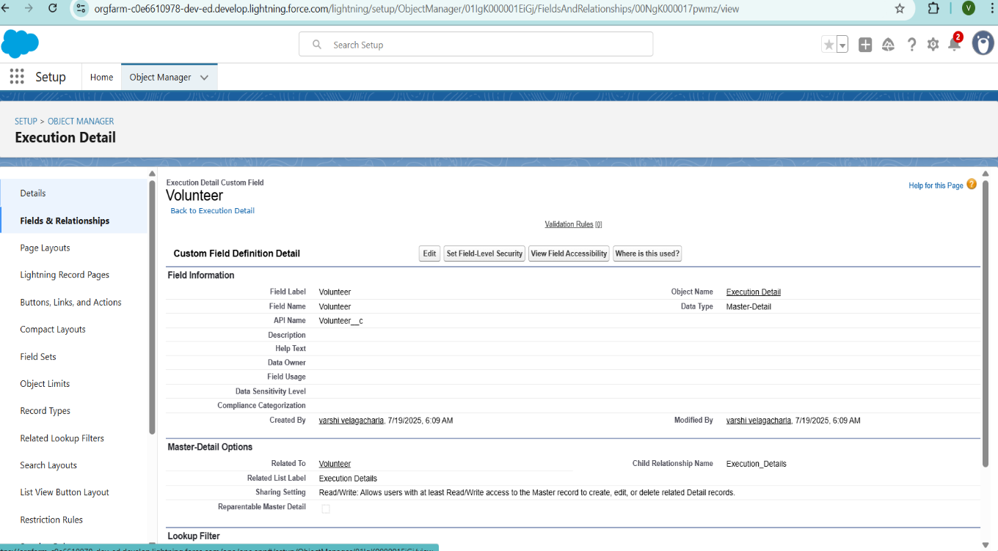

**Creation of Master Detail Relationship Field on Execution Details Object :**

1. Setup → Object Manager → Execution Details → Fields & Relationships → New.
2. Select **Master-Detail Relationship**, click **Next.**
3. Choose **Task** as the related object → click **Next.**
4. Set Field Name: **Task** (Label auto-generated) → click **Next** twice → **Save.**

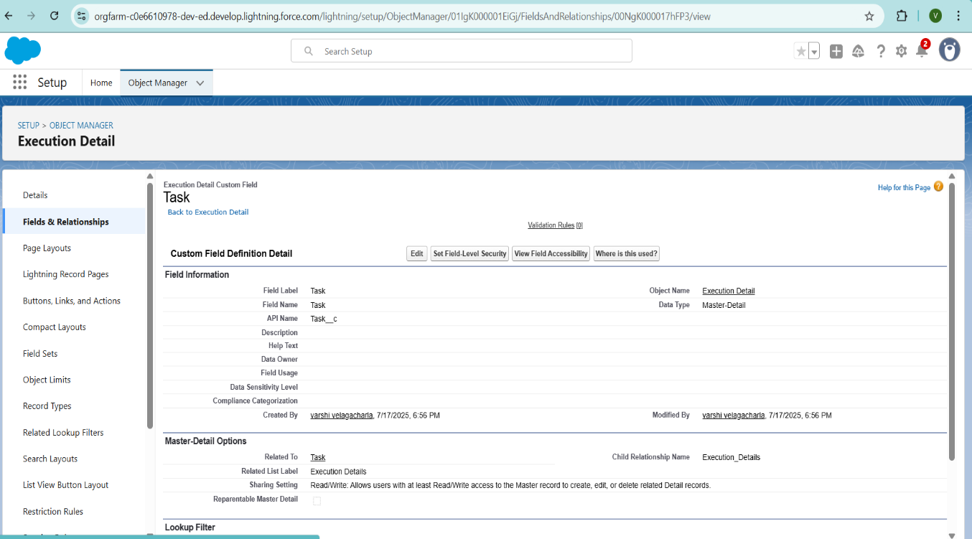

**Creation of Lookup Relationship Field on Drop-Off Point Object:**

1. Setup → Object Manager → Drop-Off Point → Fields & Relationships → New.
2. Select **Lookup Relationship**, click **Next**
3. Choose **Venue** as the related object, click **Next**
4. Field Name: **Venue**, Label auto-generated → click **Next** twice → **Save.**

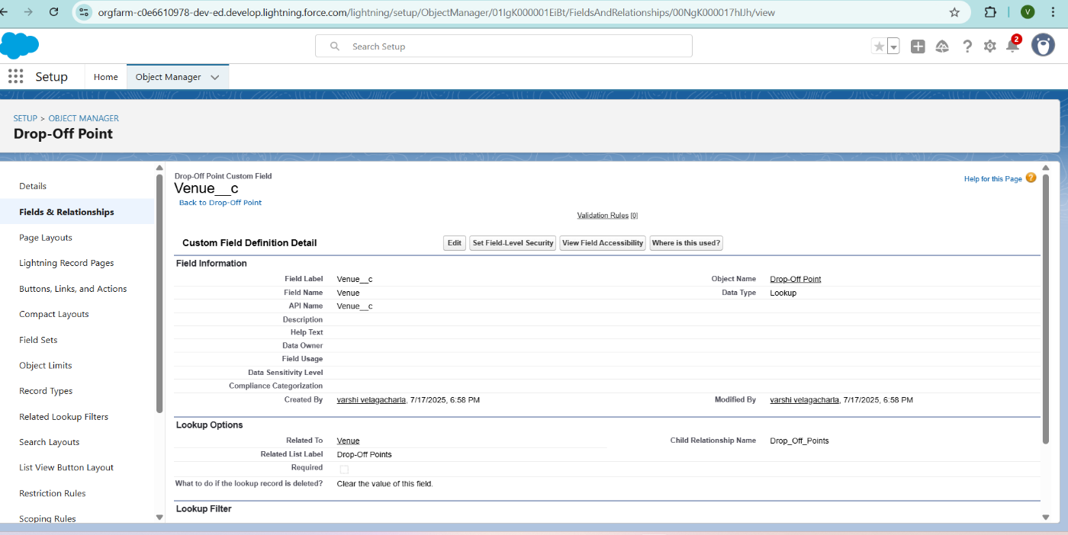

**Creation of Lookup Relationship Field on Task Object:**

1. Setup → **Object Manager → Task → Fields & Relationships → New**
2. Choose **Lookup Relationship**, then **Next**
3. Select **Venue** as the related object → **Next**
4. Field Name: **Sponsored_By** (label auto-generated) → click **Next** twice → **Save.**

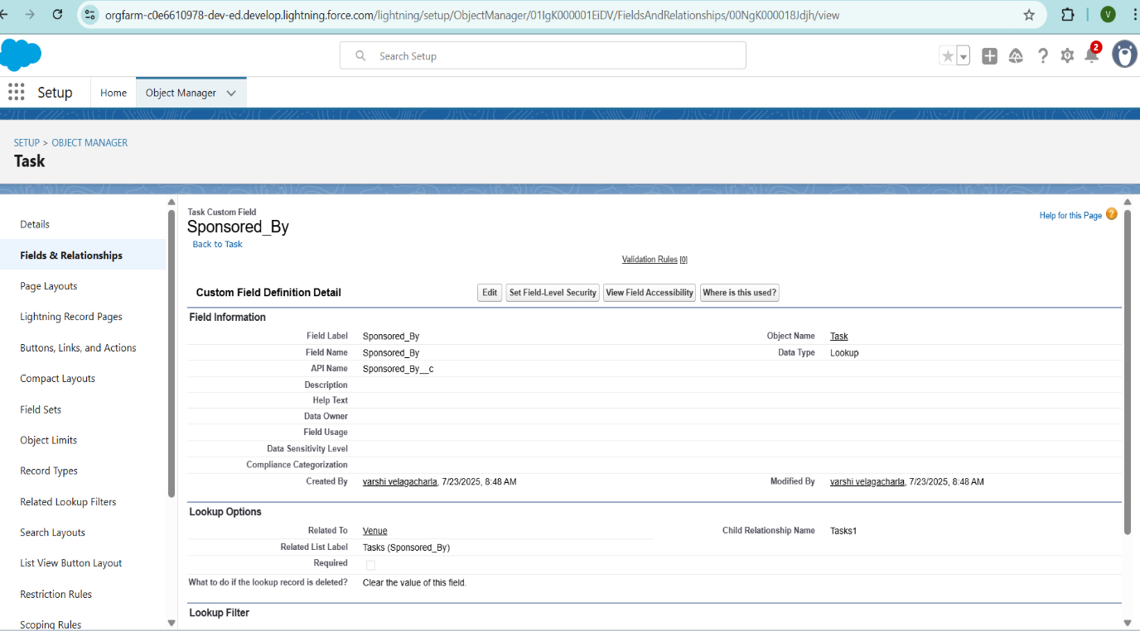

**Creation of Lookup Relationship Field on Task Object:**

1. Setup → Object Manager → Task → Fields & Relationships → New
2. Select **Lookup Relationship** → click **Next**
3. Choose **Drop-Off Point** as the related object → click **Next**
4. Field Name: **Drop_Off_Point** (label auto-generated) → **Next** twice → **Save.**

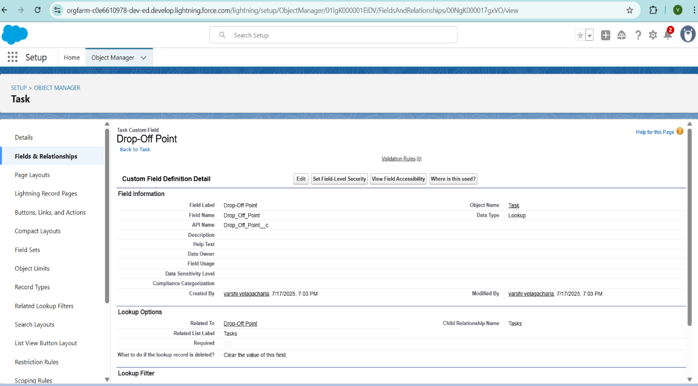

**Creation of fields for the Venue object** :

* 1. Setup → Object Manager → Venue → Fields & Relationships → New.
  2. Choose **Email** data type → **Next**
  3. Set **Field Label** & **Field Name** to **Contact Email**, mark as **Required.**
  4. Click **Next** → **Next** → **Save**

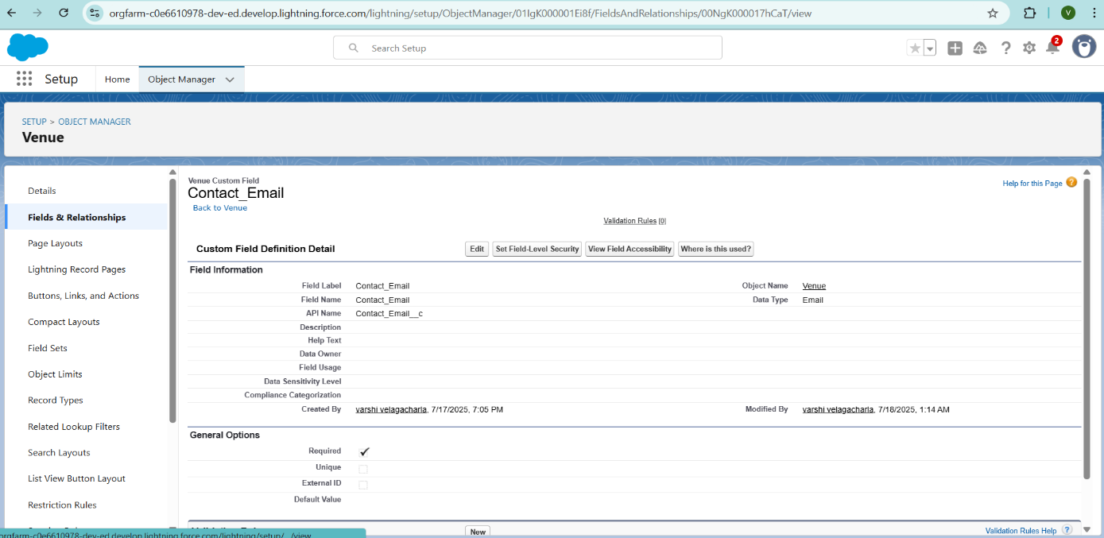

# **To create another fields in an object:**

1. Setup → Object Manager → Venue → Fields & Relationships → New.
2. Select **Phone** as the data type → **Next.**
3. Set **Field Label** and **Field Name** to **Contact Phone**, then mark as **Required**
4. Click **Next** → **Next** → **Save & New**

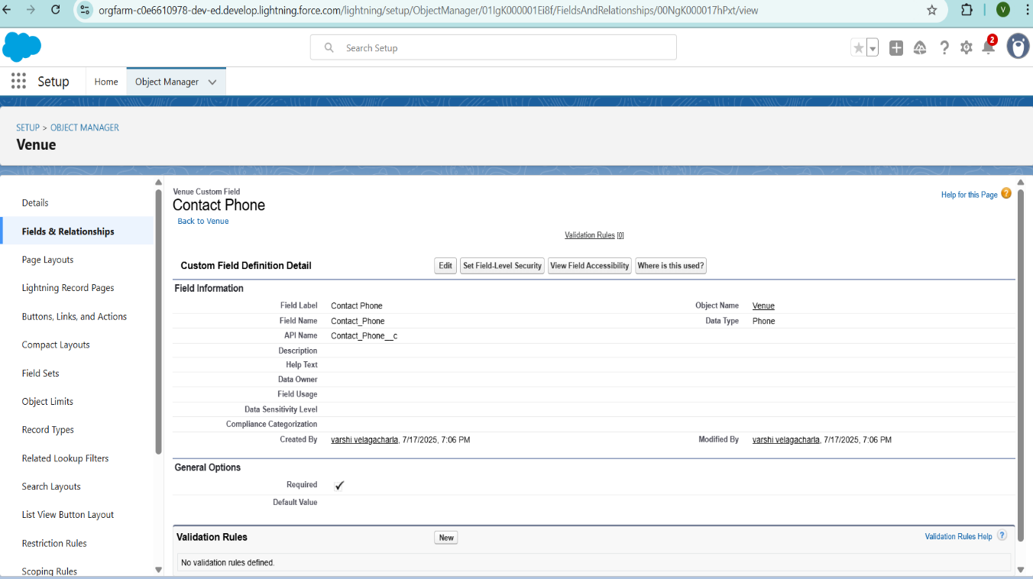

**To create another fields in an object:**

* 1. Setup → Object Manager → Venue → Fields & Relationships → New.
  2. Choose **Geolocation** as the data type → **Next**
  3. Set: **Field Label**: Location, **Decimal Places**: 4, **Field Name**: Location, **Field Name**: Location.
  4. Click **Next** → **Next** → **Save & New.**

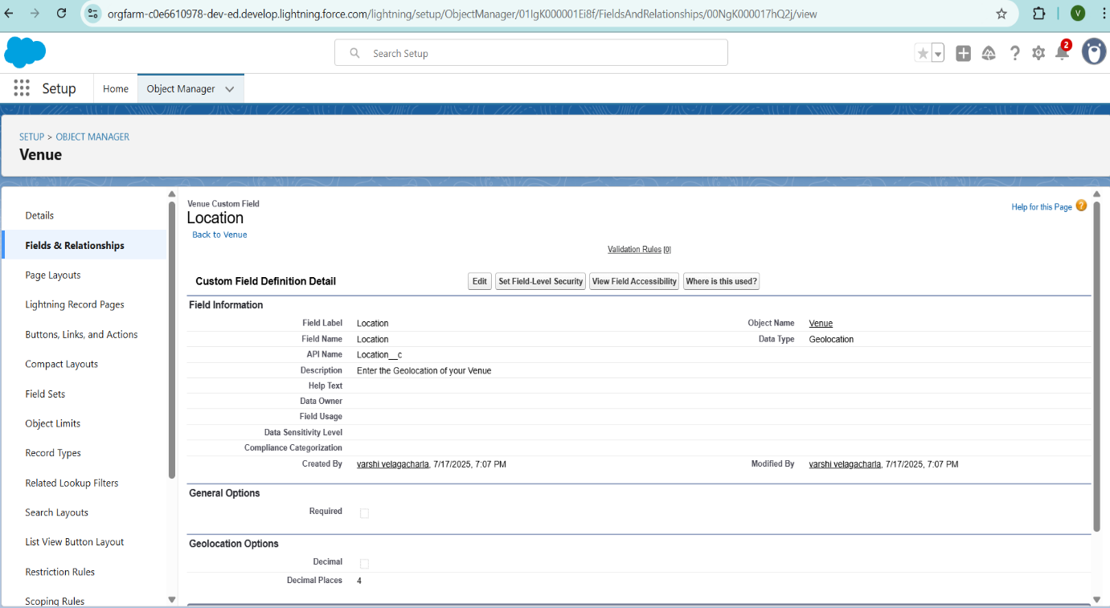

**To create other fields in an object:**

1. Setup → Object Manager → Venue → Fields & Relationships → New.
2. Choose **Long Text Area**, click **Next**
3. Enter: **Field Label**: Venue Location, **Field Name**: Venue_Location.
4. Click **Next** → **Next** → **Save** (as per Salesforce custom field creation workflow).

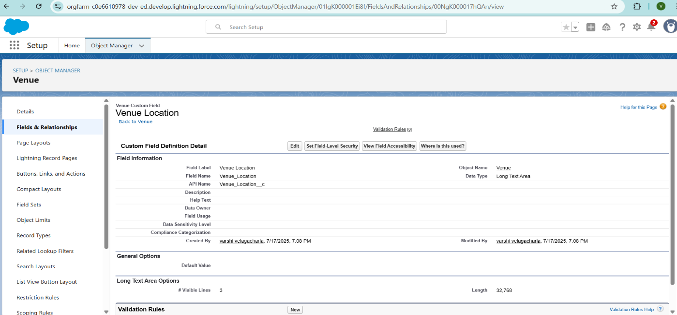

**Creation of fields for the Drop-Off point object:**

* 1. Setup → Object Manager → Drop-Off Point → Fields & Relationships → New
  2. Choose Geolocation → Next
  3. Enter: Field Label: Location 2, **Field Name**: auto-generated, **Description**: Enter the Geolocation of the Drop off Point, **Options**: Decimal, **Decimal Places**: 4.
  4. Click **Next** → **Next** → **Save & New.**

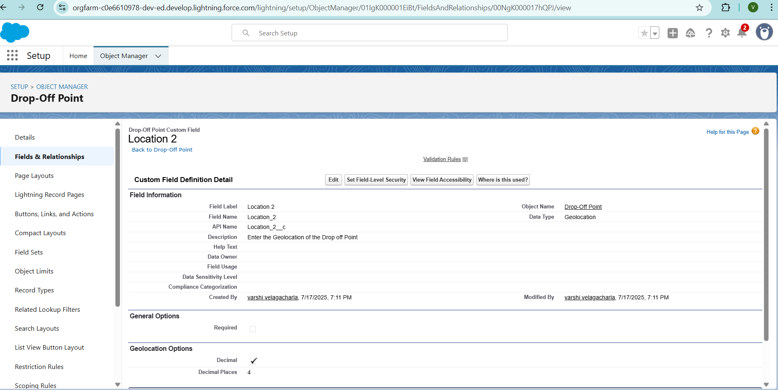

**To create another fields in an object:**

* 1. Setup → Object Manager → Drop-Off Point → Fields & Relationships → New.
  2. Choose **Formula** → **Next**
  3. Set: **Field Label**: distance calculation, **Field Name**: distance_calculation, **Return Type**: Number.
  4. In the formula editor, use: DISTANCE(Location_2__c, Venue__r.Location__c, 'km')
  5. Click **Next** → **Next** → **Save & New.**

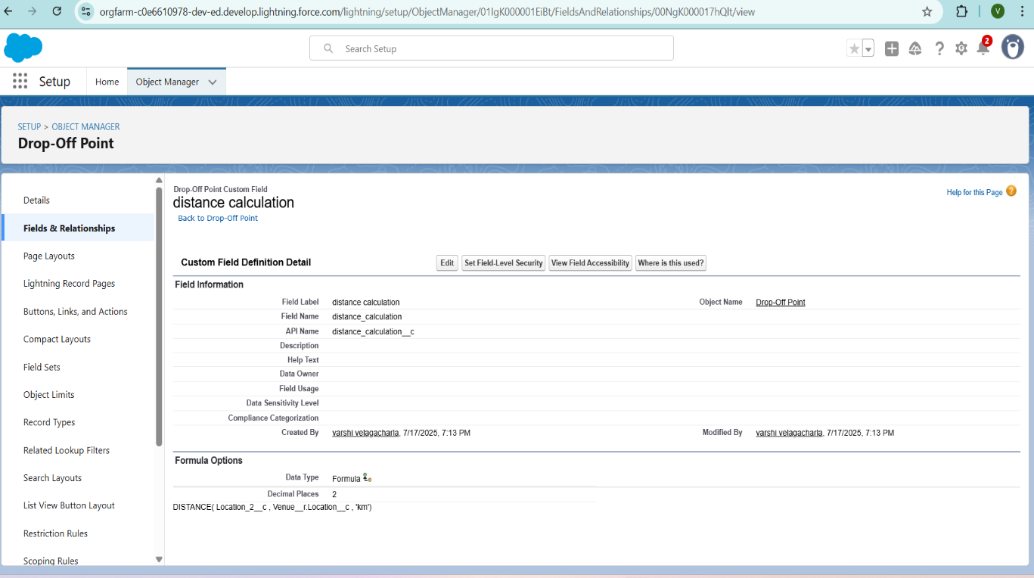

**To create another fields in an object:**

1. Setup → Object Manager → Drop-Off Point → Fields & Relationships → New.
2. Select **Picklist** → **Next**
3. Set: **Field Label**: State, **Field Name**: State, **Values**: Enter all Indian States and UTs (one per line).
4. Mark **Required** → **Next** → **Next** → **Save and new.**

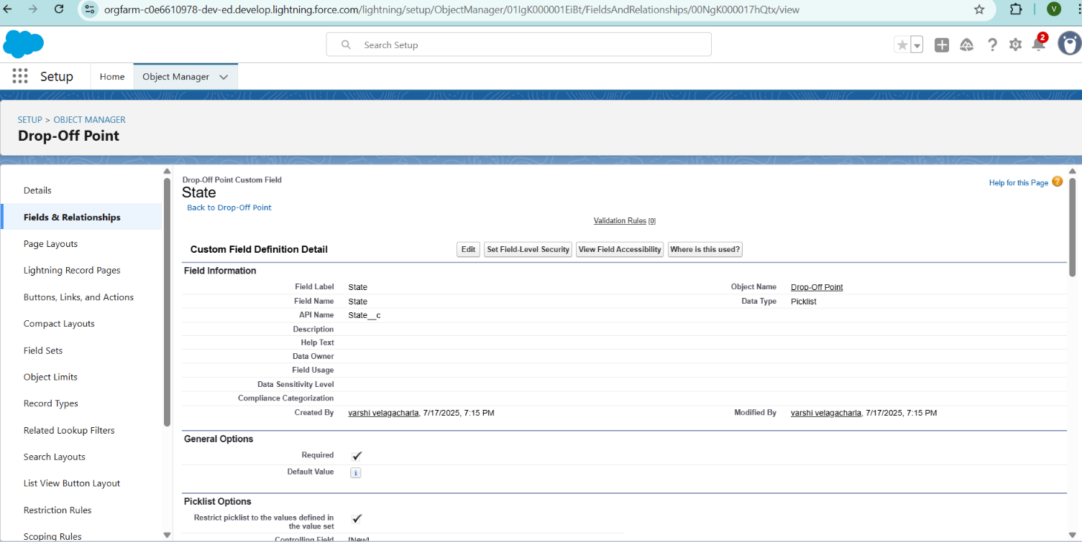

**create another fields in an object:**

1. Setup → Object Manager → Task → Fields & Relationships → New
2. Select **Number** → Next
3. Label/Name: Distance | Length: 14 | Decimal Places: 4 | Required
4. Next → Next → Save & New.

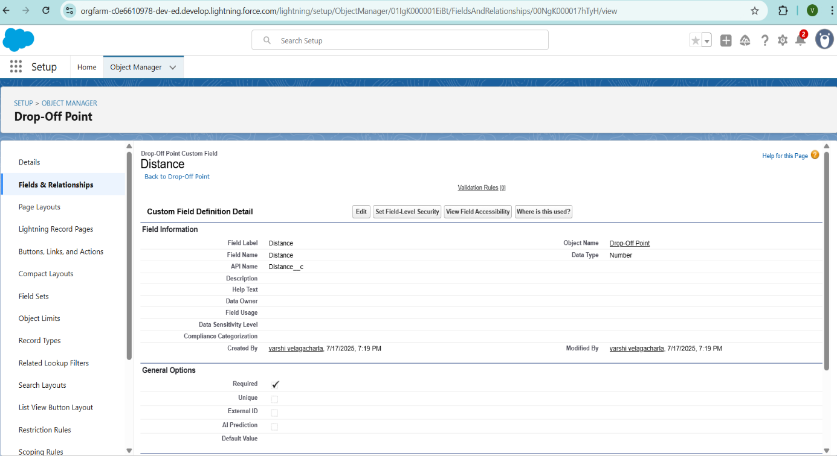

**Creation of fields for the Task object:**

1. Setup → Object Manager → Task → Fields & Relationships → New.
2. Select Auto Number →Next.
3. Label: Task ID.
4. Display Format: TASK-{0}.
5. Starting Number: 1.
6. (check Required).
7. Next → Next → Save & New.

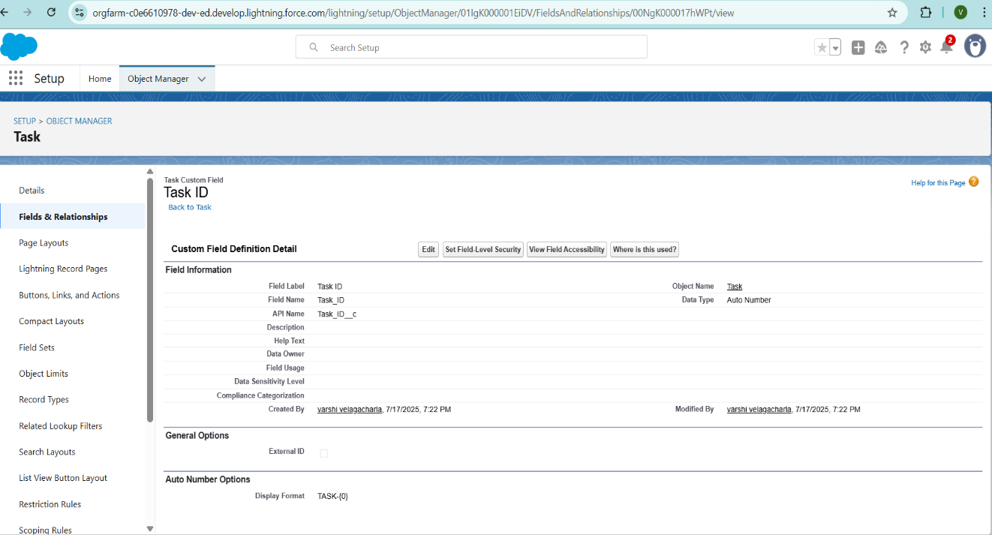

**To create another fields in an object:**

* 1. Setup → Object Manager → Task → Fields & Relationships → New
  2. Select **Date** → Next
  3. Label/Name: Date (check Required)
  4. Next → Next → Save & New.

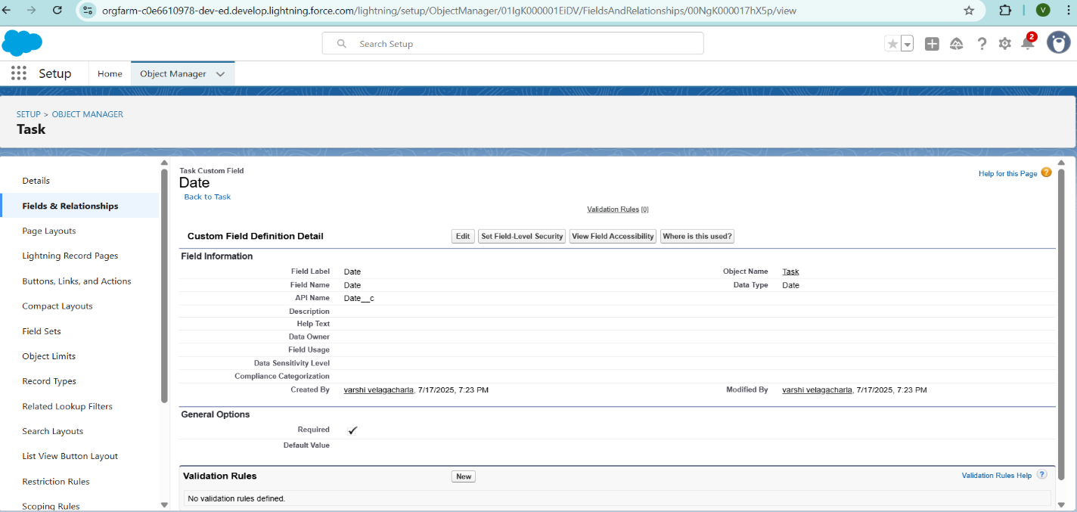

**To create another fields in an object:**

* 1. Setup → Object Manager → Task → Fields & Relationships → New
  2. Select “Picklist (Multi‑Select)” → Next
  3. Label/API Name: Food Category
  4. Values (one per line):
  5. Veg
  6. Non‑Veg
  7. Salad
  8. Snack
  9. Required → Next → Next → Save & New.

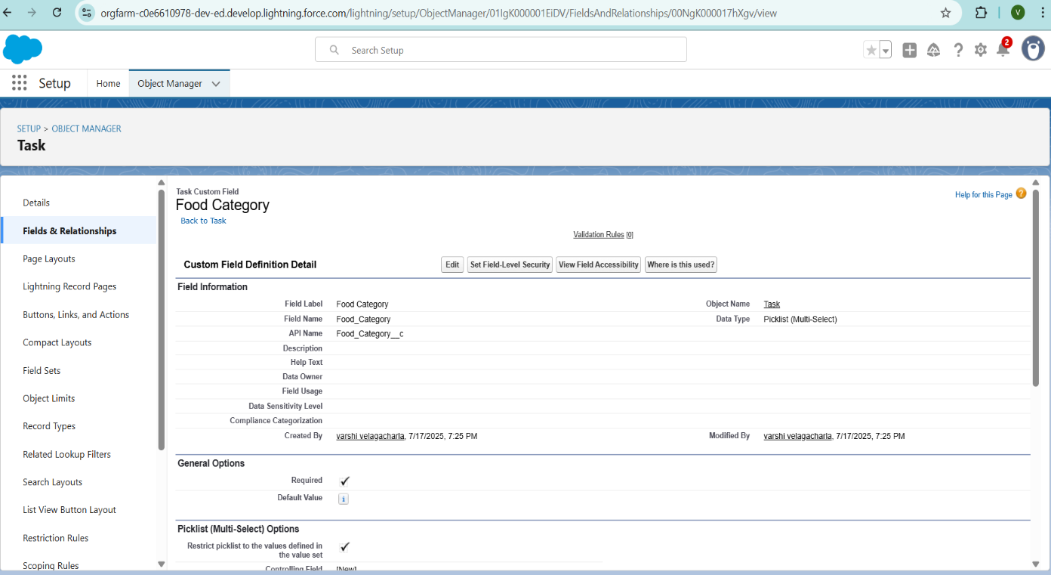

**To create another fields in an object:**

1. Setup → Object Manager → Task → Fields & Relationships → New
2. Select “Number” → Next
3. Label/API Name: Number of People Served / Number_of_People_Served
4. Required → Next → Next → Save & New.

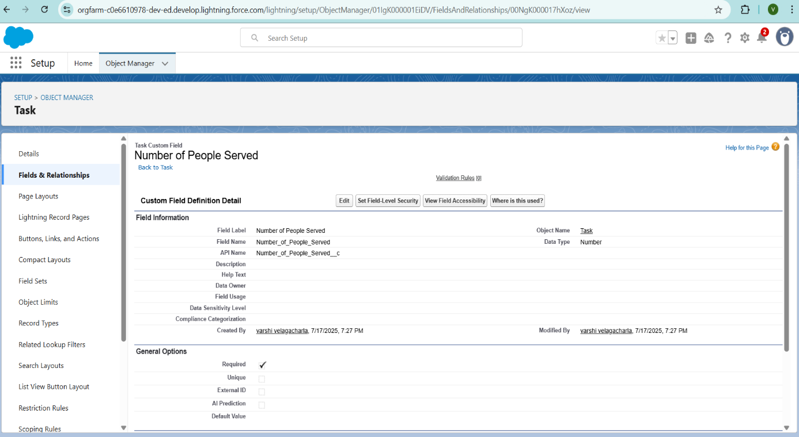

**To create another fields in an object:**

1. Setup → Object Manager → Task → Fields & Relationships → New
2. Select “Text” → Next
3. Label/API Name: Name of the Person / Name_of_the_Person
4. Next → Next → Save & New.

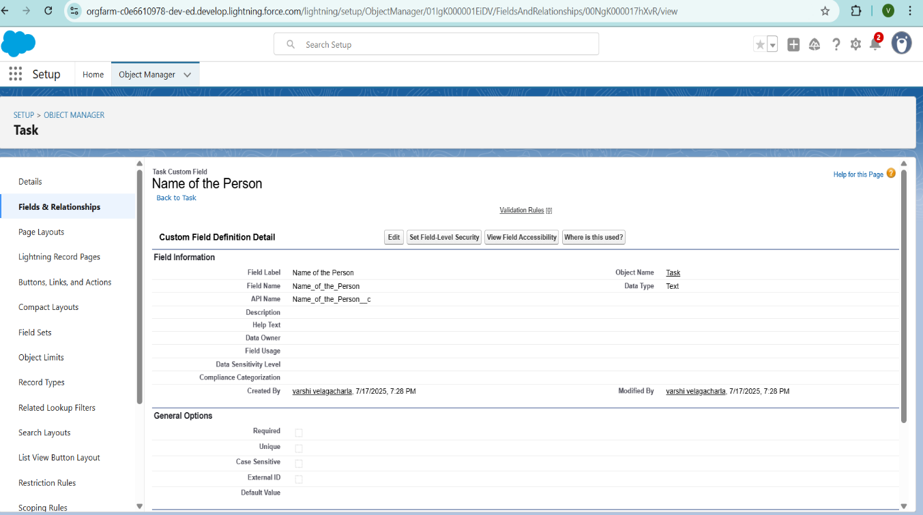

**To create another fields in an object:**

1. Setup → Object Manager → Task → Fields & Relationships → New
2. Select “Phone” → Next
3. Label/API Name: Phone
4. Next → Next → Save & New .

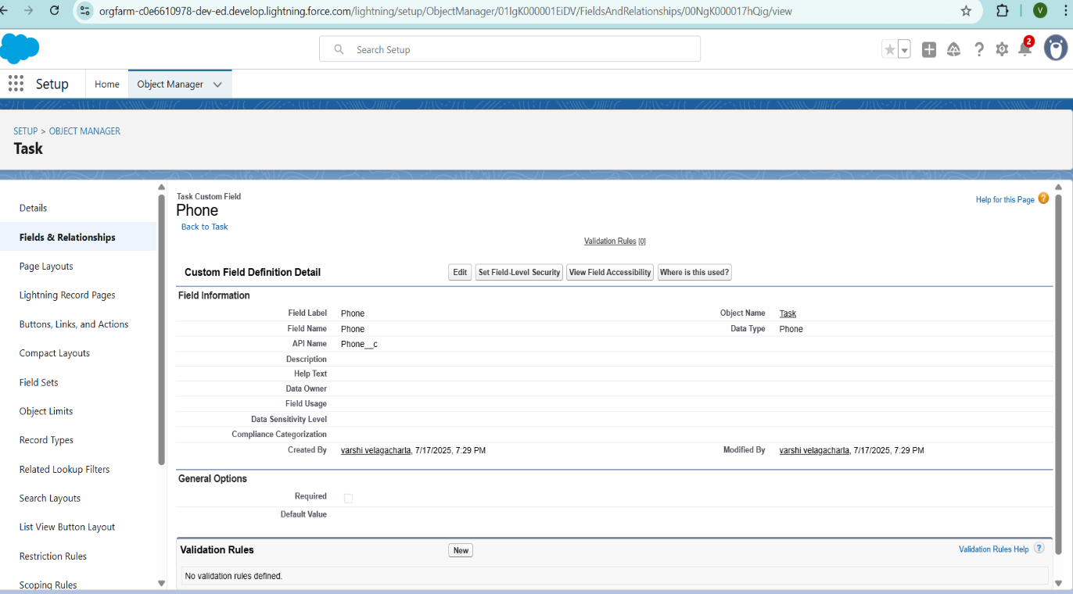

**To create another fields in an object:**

1. Setup → Object Manager → Task → Fields & Relationships → New
2. Select “Picklist” → Next
3. Label/API Name: Rating
4. Values (one per line):

30. Next → Next → Save & New.

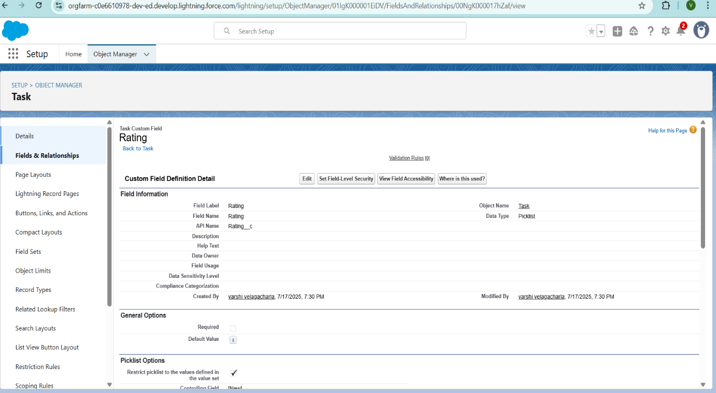

**To create another fields in an object**:

1. Setup → Object Manager → [Your Object] → Fields & Relationships → New
2. Select “Long Text Area” → Next
3. Label/API Name: Feedback
4. Next → Next → Save & New

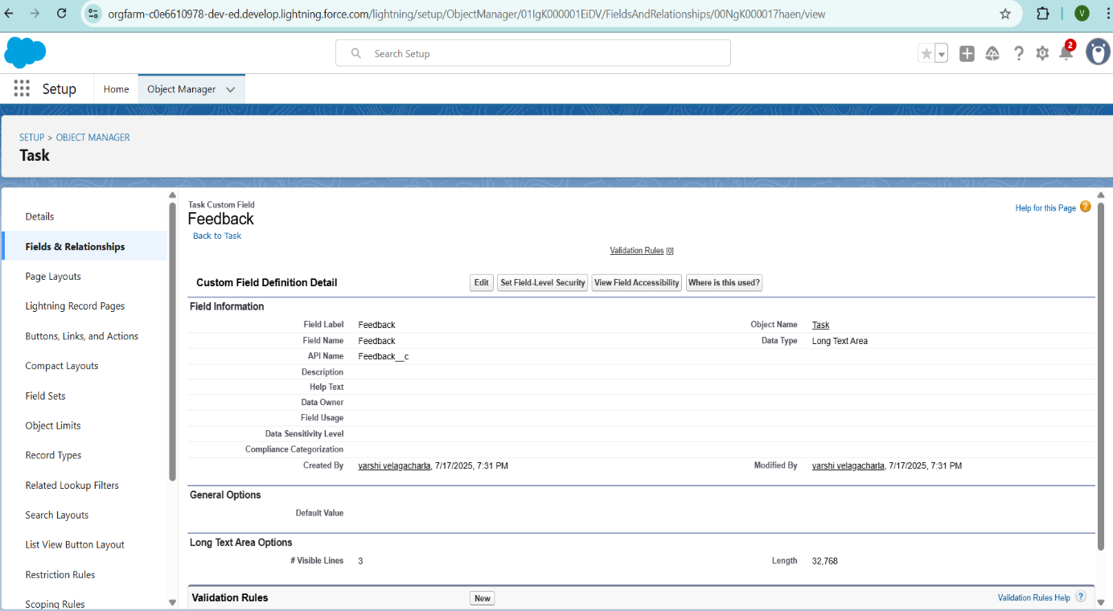

**Creation of fields for the Volunteer object:**

* + 1. **Setup → Object Manager** → search for **Volunteer** → open it.
    2. **Fields & Relationships** → **New**.
    3. Choose **Auto Number** → **Next**.
    4. Enter **Field Label** = “Volunteer ID” (Field Name auto‑fills).
    5. Check **Required** → **Next** → **Next** → **Save & New**.

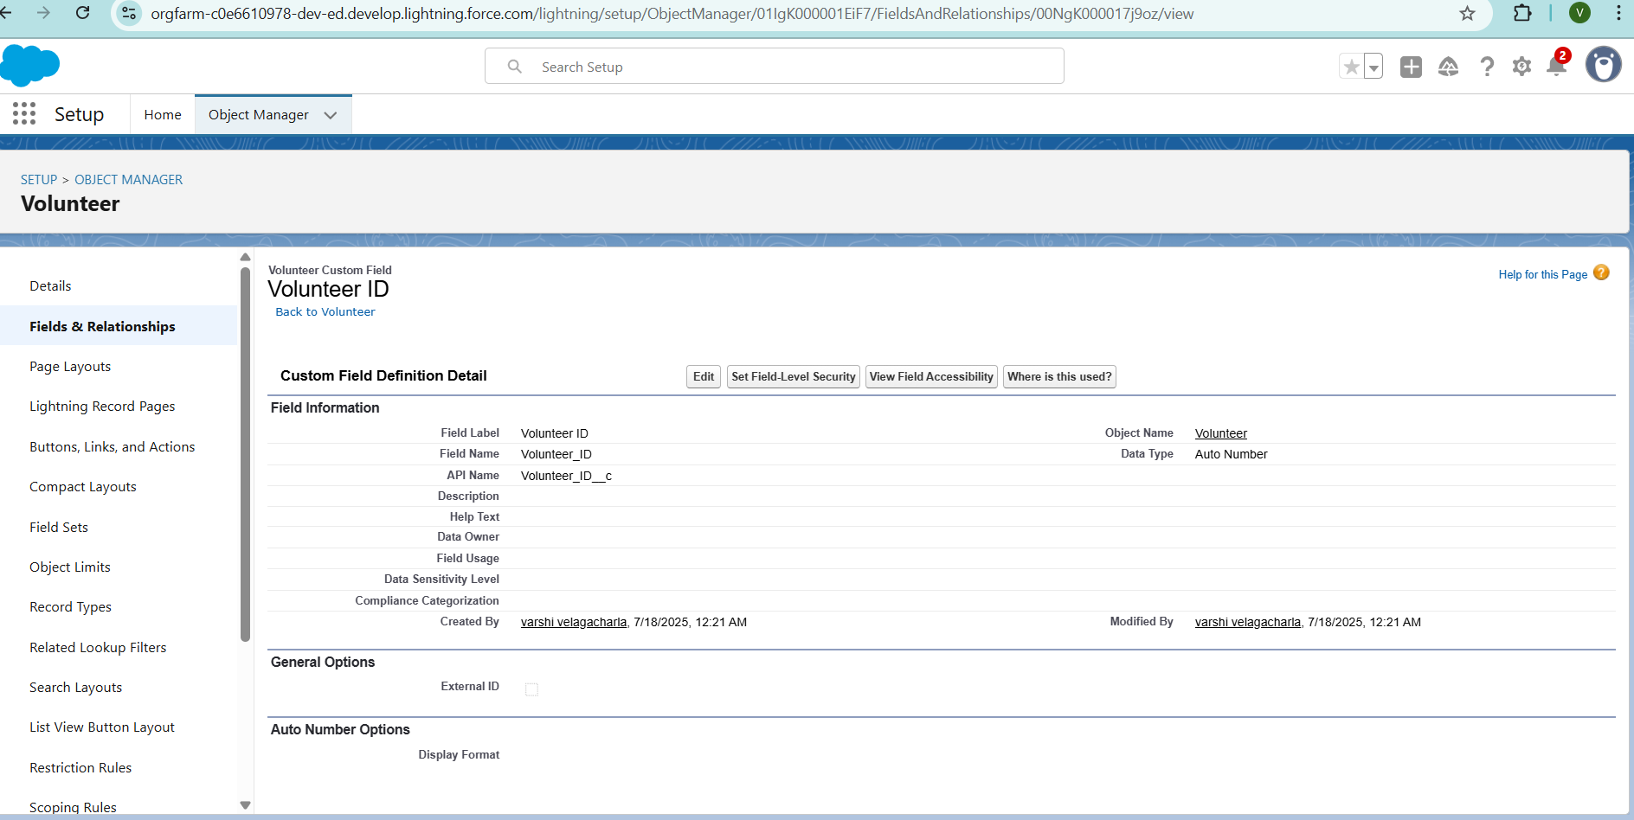

**To create another fields in an object:**

* 1. Go to **Setup** → **Object Manager** → search and select **Volunteer**.
  2. Click **Fields & Relationships** → **New**.
  3. Choose **Picklist** as the data type → **Next**.
  4. Set **Field Label** = *Gender* (Field Name auto‑fills).
  5. Under values, enter each on a new line:
  + Female.
  + Male.
  1. Click **Next** → **Next** → **Save & New.**

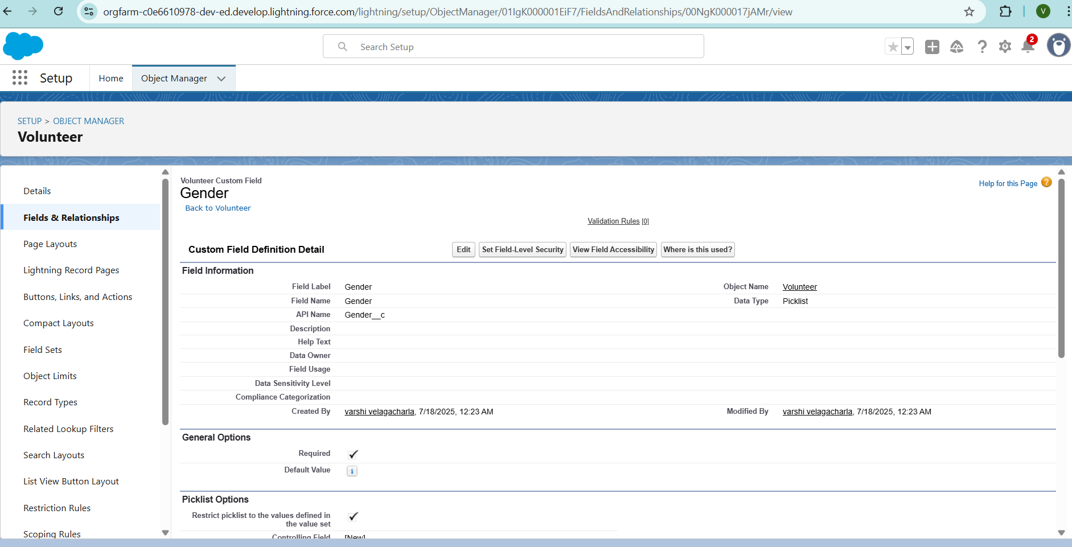

**To create another fields in an object**:

* 1. **Setup → Object Manager** → search for and select Volunteer.
  2. Click **Fields & Relationships** → **New**.
  3. Select **Date** as the data type → **Next**.
  4. Set:
  + **Field Label** = *Available On* (Field Name auto‑fills)
  + Check **Required**
  1. Click **Next → Next → Save & New** (or **Save** to finish).

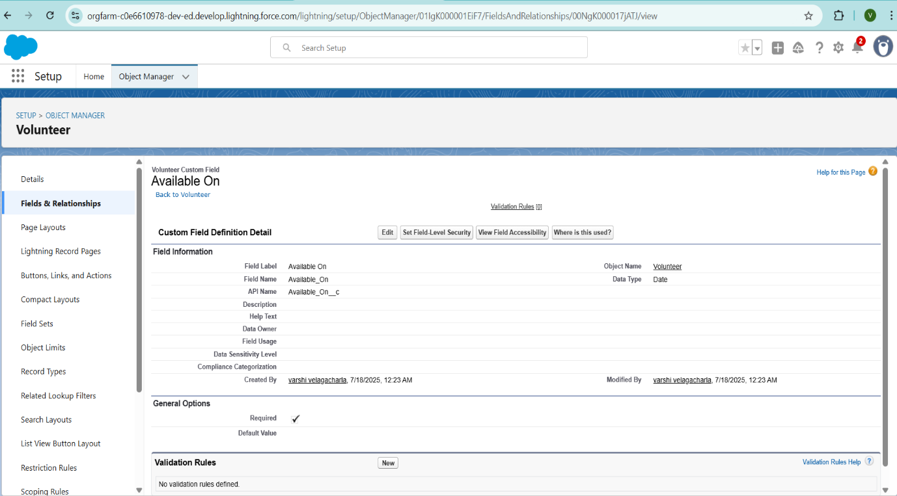

**To create another fields in an object:**

1. Setup → Object Manager → Volunteer
2. Fields & Relationships → New → Number → Next
3. Field Label: Age (API Name auto‑populates)
4. Check Required → Next → Next → Save & New.

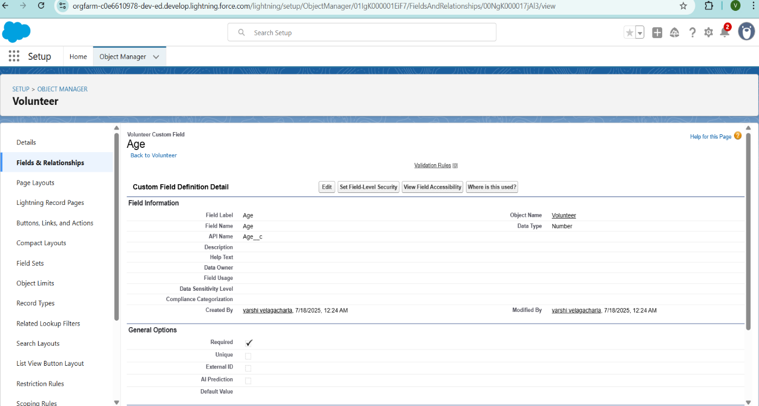

**To create another fields in an object:**

1. Setup → Object Manager → Volunteer
2. Fields & Relationships → New → Email → Next
3. Label: Email (API Name auto‑fills)
4. ✔ Required → Next → Next → Save & New.

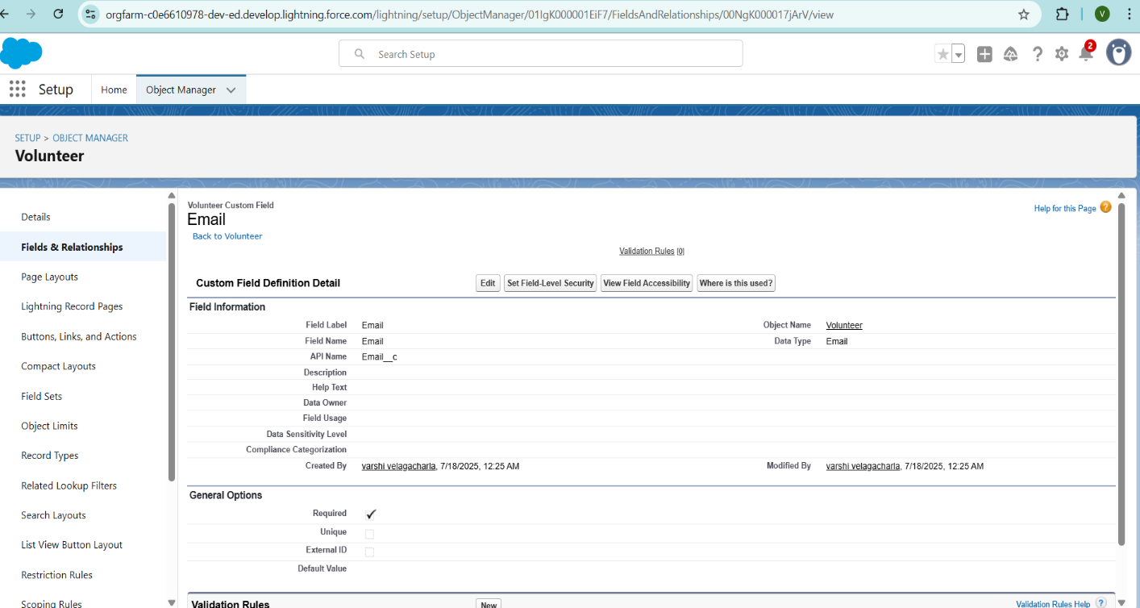

**To create another fields in an object:**

1. Setup → Object Manager → Volunteer
2. Fields & Relationships → New → Number → Next
3. Label: Contact Number (API Name auto‑fills)
4. ✔ Required → Next → Next → Save & New.

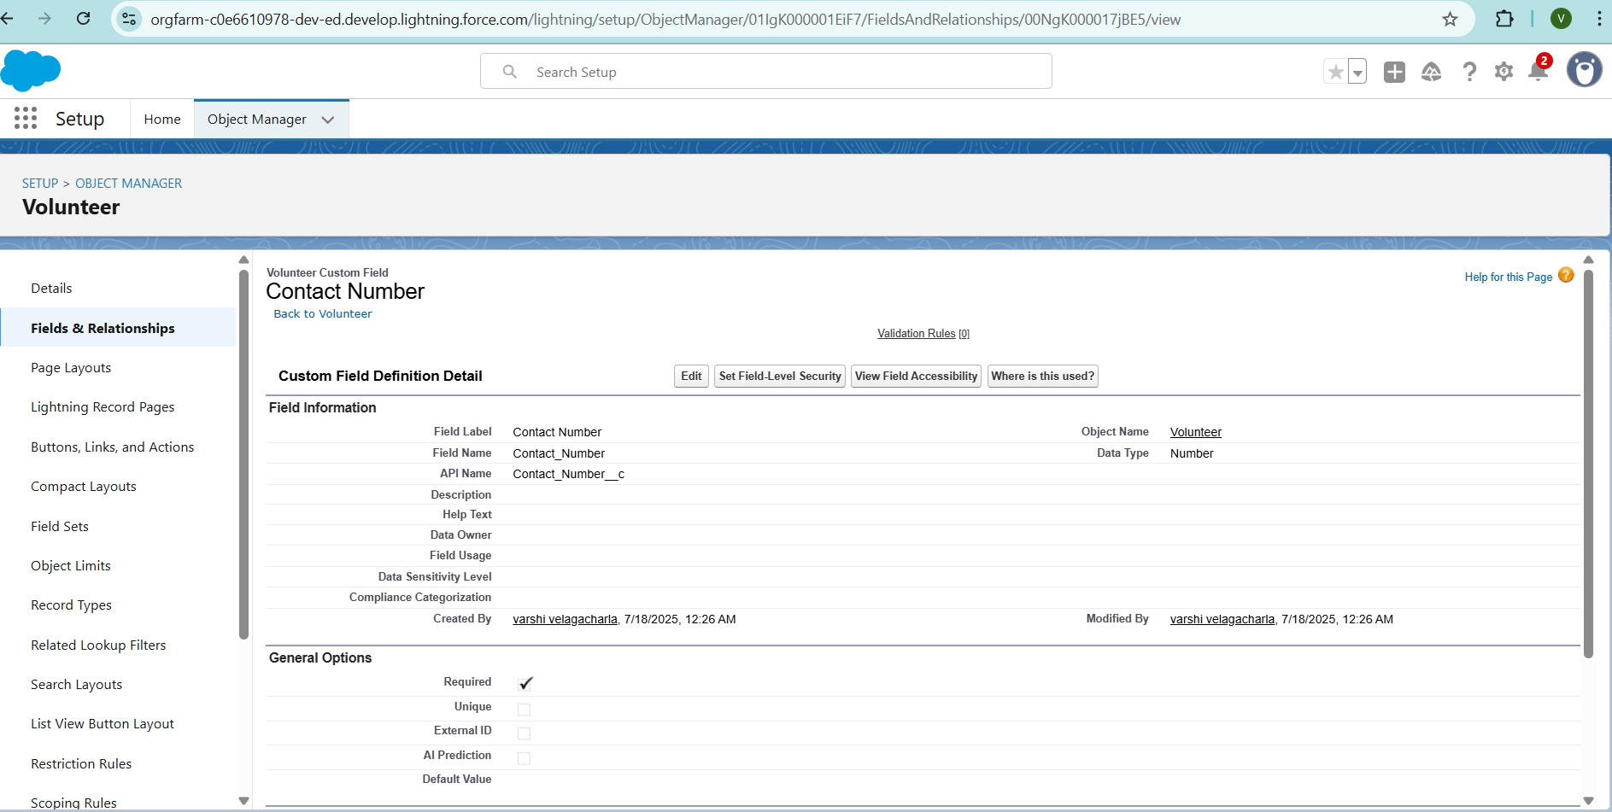

**To create another fields in an object:**

1. Setup → Object Manager → Volunteer
2. Fields & Relationships → New → Text Area (Long) → Next
3. Label: Address (API Name auto‑fills)
4. Next → Next → Save & New.

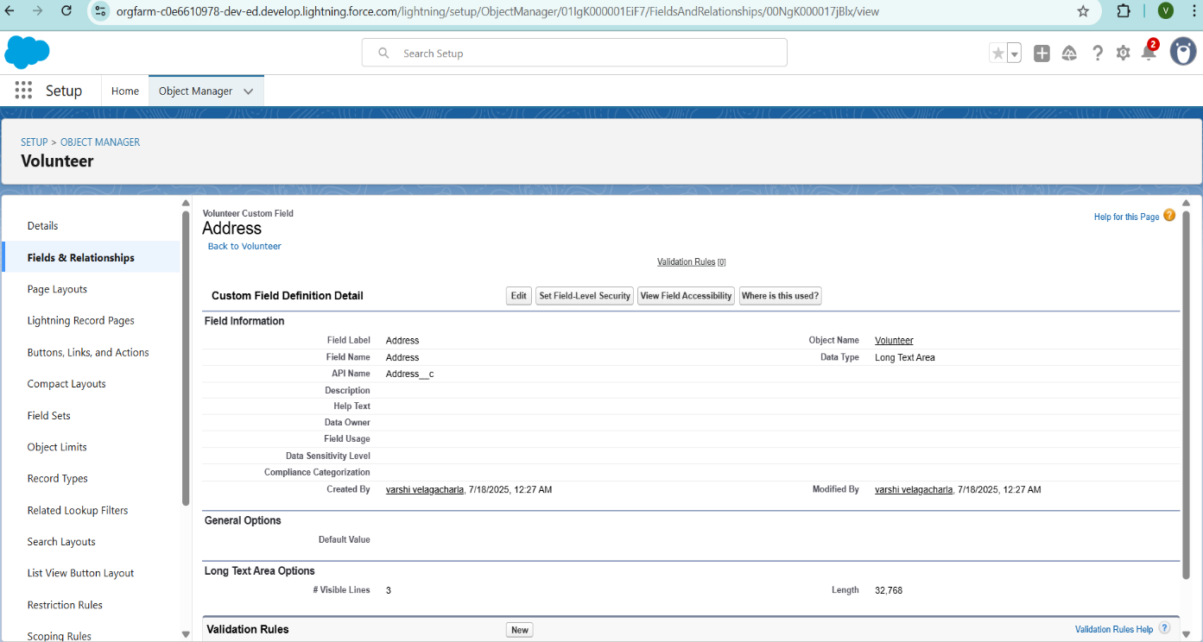

**To create another fields in an object:**

1. Setup → Object Manager → Volunteer
2. Fields & Relationships → New → Date → Next
3. Label: Date of Birth (API Name auto‑fills)
4. Next → Next → Save & New.

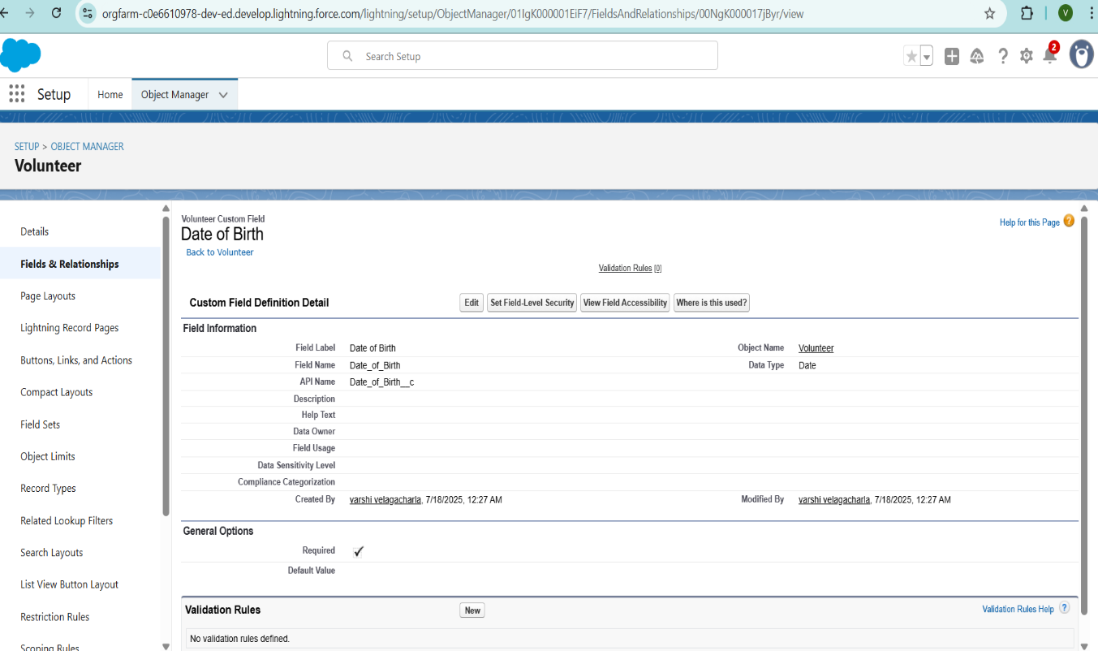

**Creation of fields for the Execution Details object:**

1. Setup → Object Manager → Volunteer
2. Fields & Relationships → New → Auto Number → Next
3. Label: Execution ID (Name auto‑fills)
4. ✔ Required → Next → Next → Save & New.

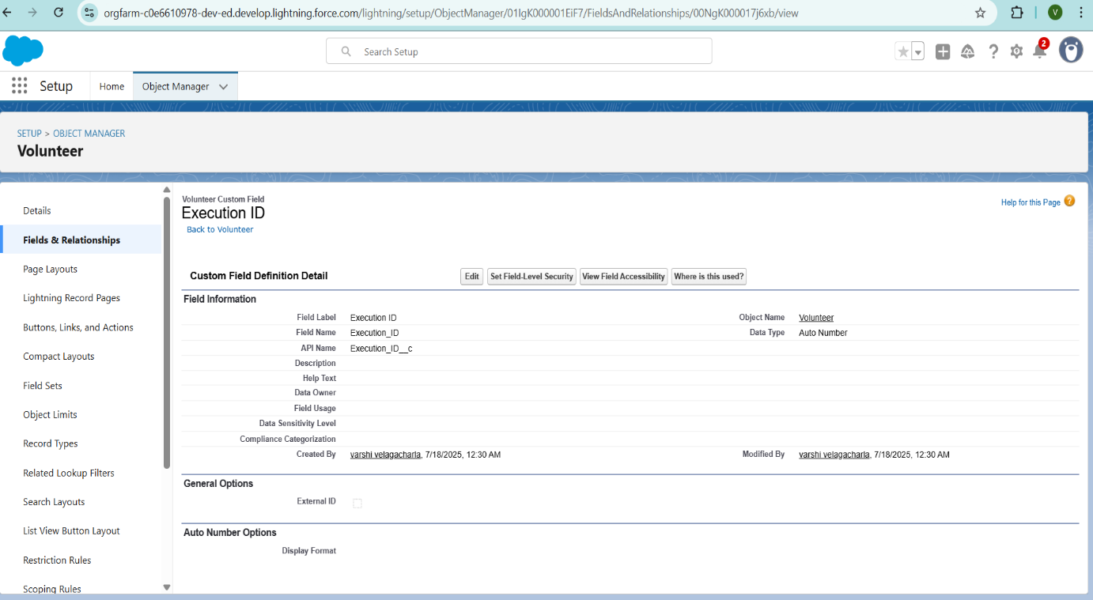

**Create Flow to create a record in Venue object**

* 1. Go to setup >> type Flow in quick find box >> Click on the Flow and Select the New Flow.
  2. Select the Screen flow. Click on create.
  3. Click on the ‘+’ icon in between start and end and click on screen element.
  4. Under the Screen Properties:

Label: Venue Details

API Name: Venue_Details

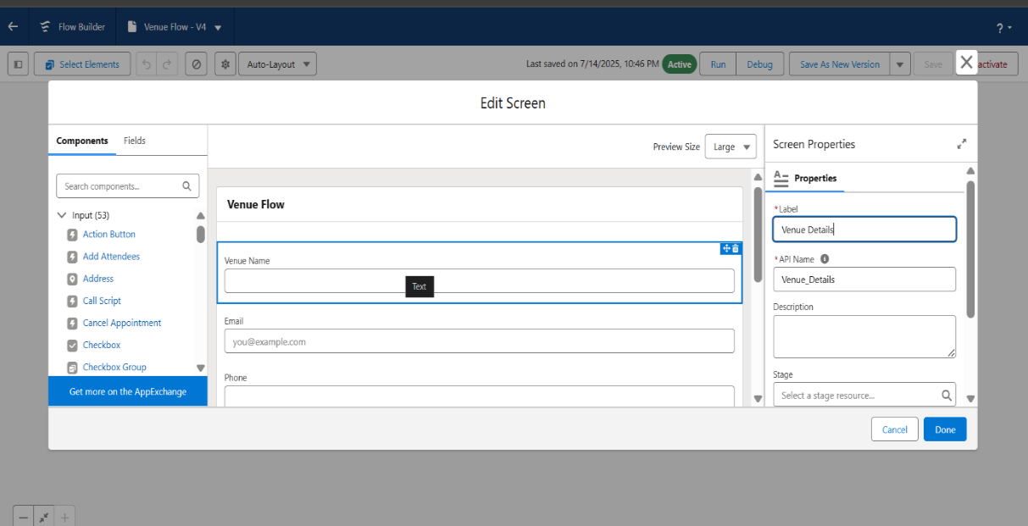

* 1. Now let’s add components in this flow. Click on Text Component and name it as:

Label: Venue Name

API Name: Venue_Name

* 1. Click on Email Component and name it as:

Label: Email

API Name: Contact_Email

* 1. Click on Phone Component and name it as:

Label: Phone

API Name: Contact_Phone

* 1. Click on Text Component and name it as:

Label: Venue Location

API Name: Venue_Location

* 1. Click on Number Component and name it as:

Label: Latitude

API Name: Latitude

* 1. Click on Number Component and name it as:

Label: longitude

API Name: longitude

* 1. Next click on Done. This would like below
  2. Click on the ‘+’ icon in between Venue details and end and click on create record element.
  3. Now label it as

Label: Create Venue Record

API Name: Create_Venue_Record

How Many Records to Create: One

How to Set the Record Fields: Use separate resources, and literal values

Object: Venue

Set Field Values for the Venue: Click on ‘Add Field’ 5 times

Field: Value = Contact_Email__c : {! Contact_Email.value} Field: Value = Contact_Phone__c : {! Contact_Phone.value}

Field: Value = Name: {! Venue Name}

Field: Value = Venue_Location__c : {! location}

Field: Value = Location__Latitude__s : {! latitude}

Field: Value = Location__Longitude__s : {!longitude}

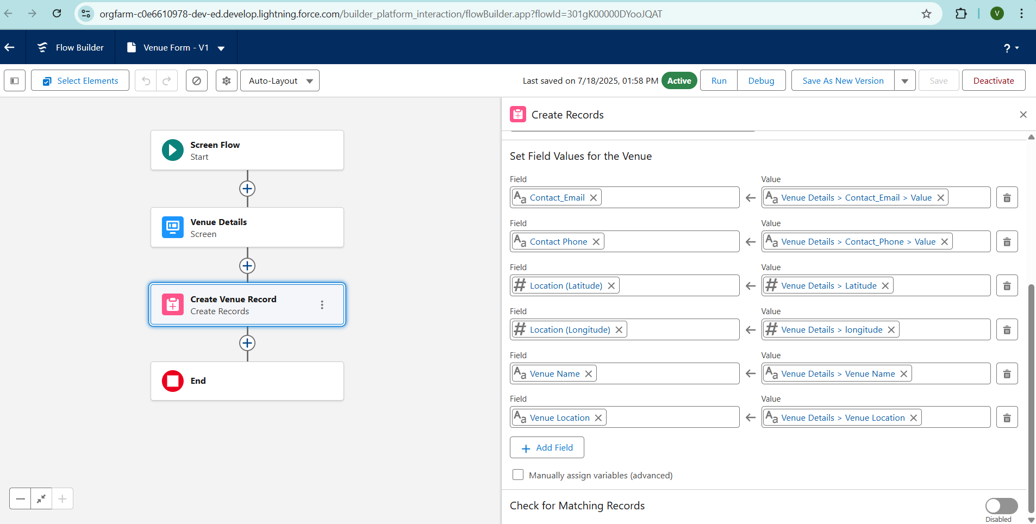

1. This would look like:
2. Click on Save as:

Flow Label: Venue Form

Flow API Name: Venue_Form

**Apex Classes, Triggers, Asynchronous Apex:**

Custom Apex triggers were developed to automatically update stock status and generate distribution records when a pickup is marked completed. Additionally, asynchronous Apex (Batch Apex) was implemented to periodically send summary emails to donors and NGOs highlighting food saved and beneficiaries served over the week. This ensures timely communication and promotes continued engagement without impacting real-time system performance.

**Create a Trigger**

* 1. Setup → Gear icon → Developer Console
  2. File → New → Apex Trigger
  3. Trigger Name: DropOffTriggers
  4. sObject: Drop‑Off Point
  5. Click Submit

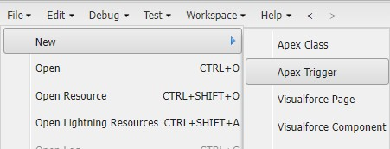

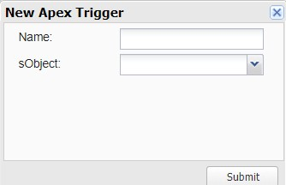

**Trigger Code**

(This Trigger is to assign Distance field to the Distance Calculation field. So that we can assign the distance in the sharing rules.)

**Code:**

trigger DropOffTrigger on Drop_Off_point__c (before insert) { for(Drop_Off_point__c Drop : Trigger.new){

Drop.Distance__c = Drop.distance_calculation__c;

}

}

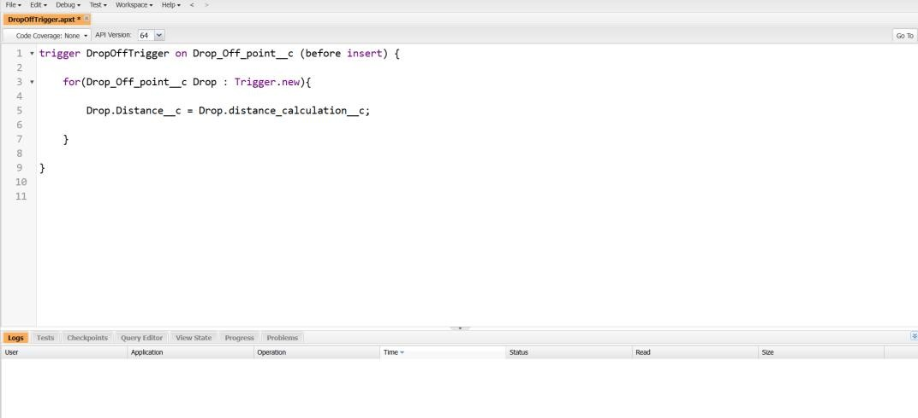

**Phase 3:UI/UX Development & Customization:**

**Create a Lightning App**

To create a lightning app page:

1. Setup → Quick Find: App Manager → Click “App Manager”
2. Click “New Lightning App”.

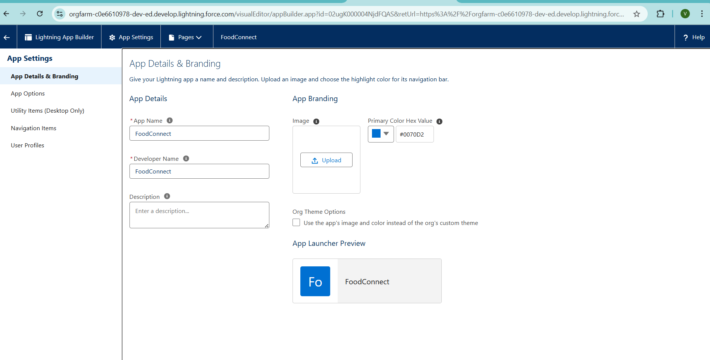

1. App Details & Branding.
   * **App Name:** FoodConnect.
   * **Developer Name:** auto-populates.
   * **Image:** optional.
   * **Primary Color :** keep as default.

1. Navigation Style.
   * Click **Next.**
   * On the App Options page, choose **Navigation Style: Standard Navigation.**
   * Click **Next.**

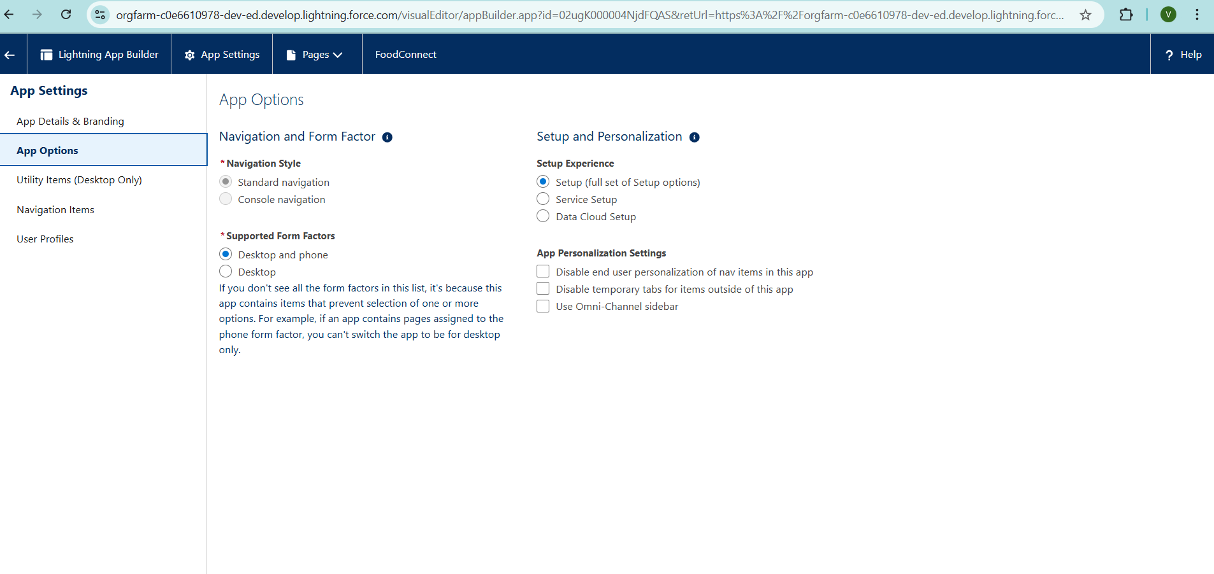

1. (Utility Items) keep it as default >> Next.
2. To Add Navigation Items:

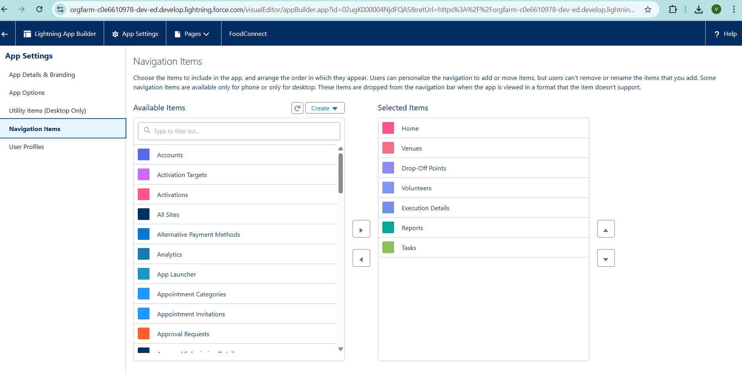

Search for the item in the (Home, Venue, Drop-Off Point, Task, Volunteer, Execution Details, Reports) from the search bar and move it using the arrow button >> Next >> Next.

1. To Add User Profiles:

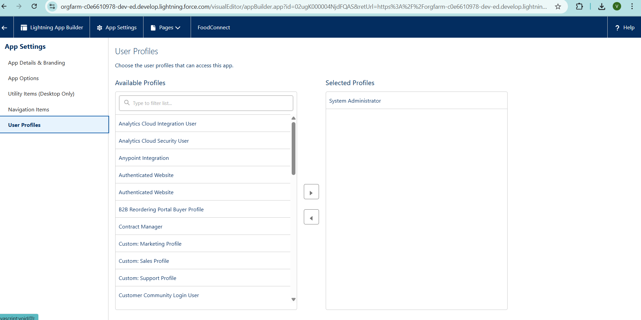

Search profiles (System administrator) in the search bar >> click on the arrow button >> save & finish.

**Creation of Report on Venue with DropOff with Volunteer**

1. Go to the app (FoodConnect) >> click on the reports tab

* 1. Click on New Folder.

Folder Label: Custom Reports

Folder Unique Name: CustomReports

3. Open Custom Reports and click on New Report

4. Select Report Type: Venue with DropOff with Volunteer

5. Then click on Start Report.

6. In GROUP ROWS: Add Volunteer Name

7. In Columns: Add Venue Name, Drop-Off point Name, Distance.

8. Now click on Save & Run.

9. Give Label as:

10. Report Name: venue and Drop Off point

11.Report Unique Name: Auto Populated

Click on Select Folder and select Custom Report, then click on Save.

**Creation of Report on Volunteers with Execution Details and Tasks**

* + 1. Go to the app (FoodConnect) >> click on the reports tab

2 . Click on Custom Reports Folder and click on New Report 3. Select Report Type: Volunteers with Execution Details and Tasks.

* 1. Then click on Start Report.
  2. In GROUP ROWS: Volunteer ID
  3. In Columns: Add Volunteer: Volunteer Name, Task: Task Name, Execution Detail : Execution Detail Name, Volunteer: Owner Name, Task: Date, Task : Rating.

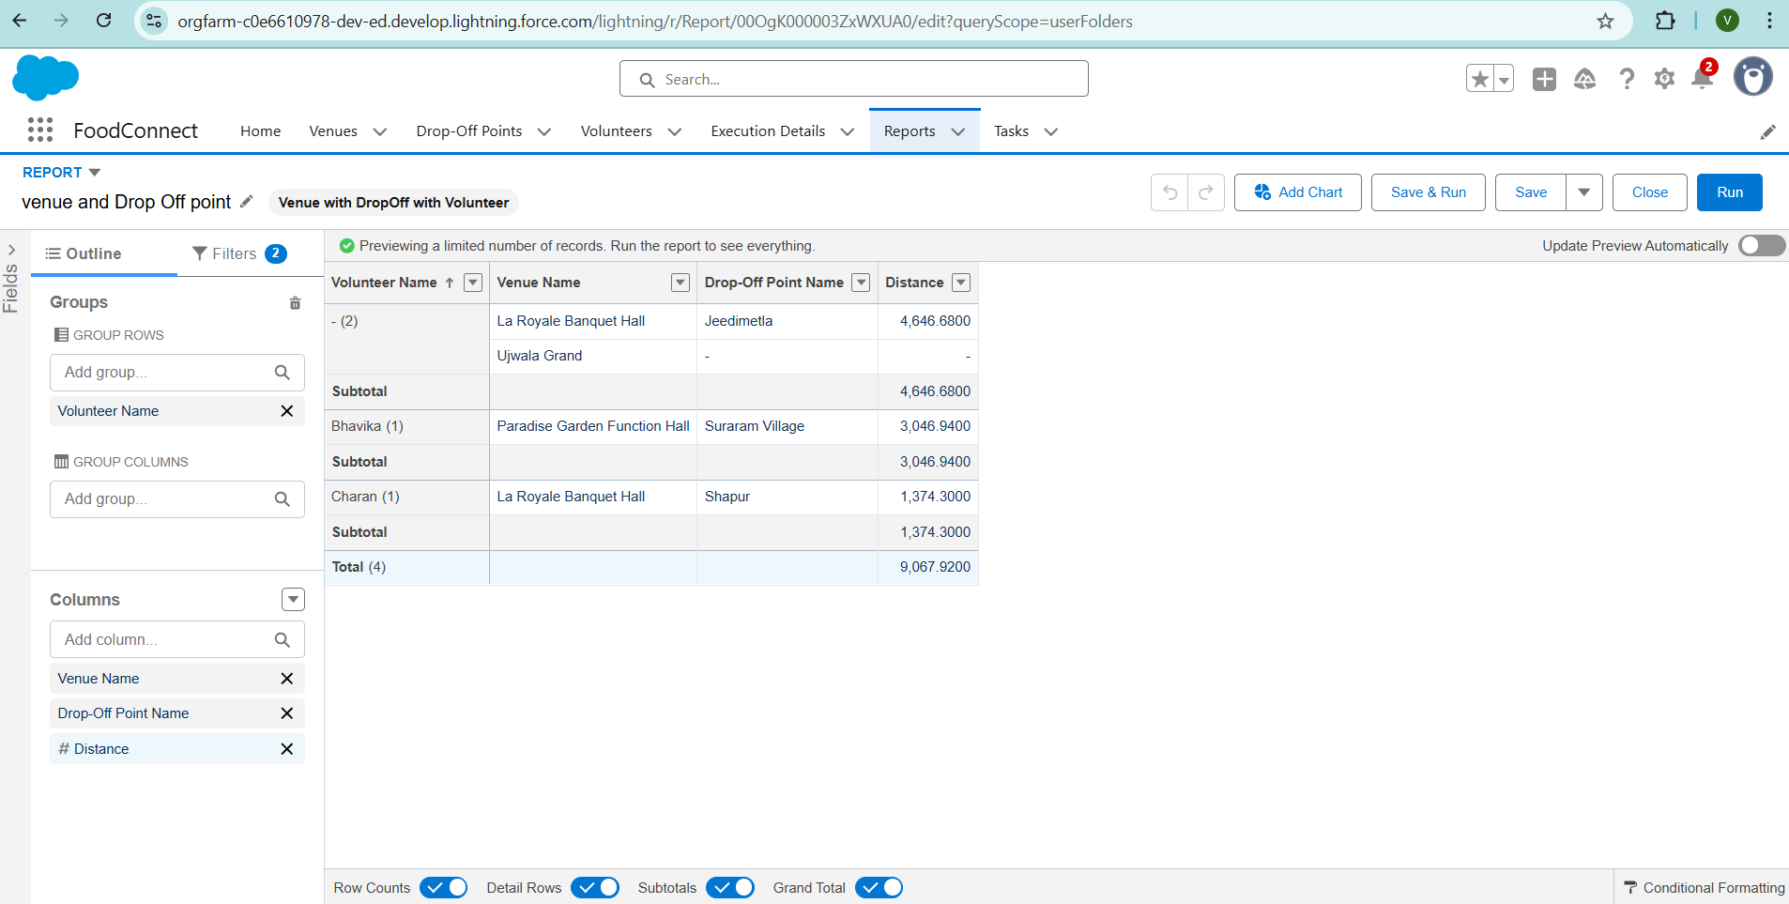

* 1. Now click on Save & Run.
  2. Give Label as:

Report Name: Volunteer Task

Report Unique Name: Auto Populated

* 1. Click on Select Folder and select Custom Report, then click on Save.

**Adding venue and Drop Off point Report to the Dashboard** 1. Go to the app (Food Connect) >> click on the Dashboards tab.

* 1. Click on New Folder.

Folder Label: Custom Dashboards

Folder Unique Name: Auto Populated

* 1. Open Custom Dashboards and click on New Dashboards
  2. Name: Organization Details
  3. Click on Widget and select Chart or Table
  4. In Select Report: Select venue and Drop Off point Report.
  5. Then click on select
  6. In Add Component:

Display As: Select Lightning Table

Component Theme: Select Dark (Optional)

1. Now click on save.
2. You can see in Analytics tab also (optional)

**Adding Volunteer Task Report to the Dashboard**

* + 1. Click on Widget and select Chart or Table
    2. In Select Report: Select Volunteer Task Report.
    3. Then click on select
    4. In Add Component:

Display As: Select Line Chart

Component Theme: Select Dark (Optional)

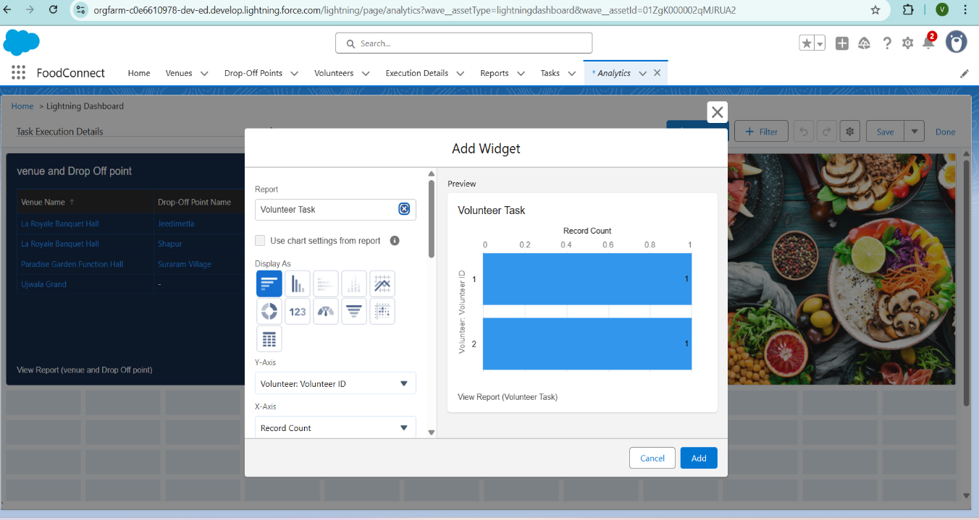

1. Now click on save.

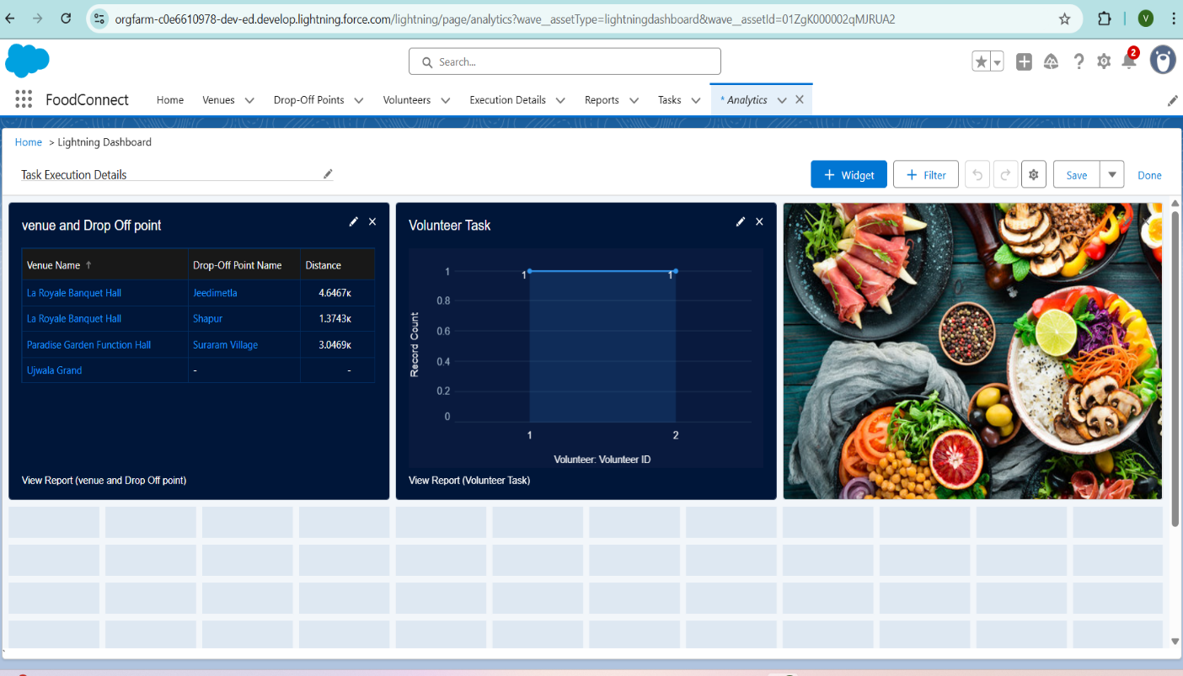

**Phase 4: Data Migration, Testing & Security Data Loading Process:**

Historical data of partner restaurants, NGOs, and past donation records was migrated into Salesforce using the Data Loader, chosen for its capability to handle bulk records and ensure referential integrity across custom objects like Food Donation, Pickup Schedule, and Distribution Record. This ensured a smooth transition from manual tracking systems to the new automated CRM.

**Field History Tracking, Duplicate Rules, Matching Rules:**

Field History Tracking was enabled on key objects such as Food Donation and Pickup Schedule to maintain an audit trail of critical changes like pickup time adjustments or status updates. Duplicate Rules and Matching Rules were configured on the Donor and Recipient records to prevent redundant entries and ensure that every partner is uniquely identified, thereby preserving data quality.

**Profiles, Roles, Role Hierarchy, Permission Sets, Sharing Rules:**

A robust security model was implemented using Salesforce Profiles and Roles. Profiles controlled baseline access for different users like restaurant managers, NGO coordinators, and volunteer drivers. A Role Hierarchy was established to allow NGO managers to view records of volunteers under them while keeping data compartmentalized across different NGOs. Permission Sets were used to grant additional privileges, such as access to dashboards for analytics teams, while Sharing Rules ensured specific records (like a Pickup Schedule) could be shared with relevant volunteers automatically.

**Profiles**

1. Setup → Quick Find “Profiles” → Profiles
2. Find “Standard Platform User” → Clone
3. Enter Profile Name: NGOs Profile
4. Click Save

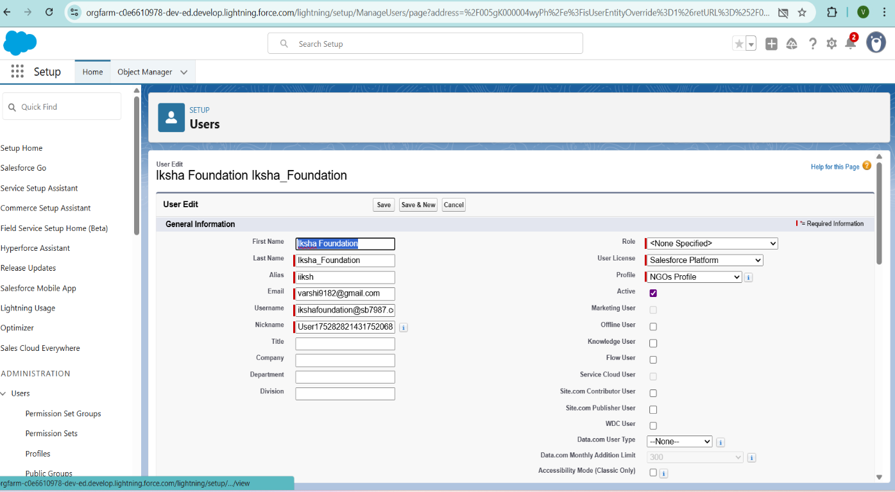

**Creation of User2, User3**

1. Create another Two Users by following steps in Activity - 1 with similar User License and Profile.

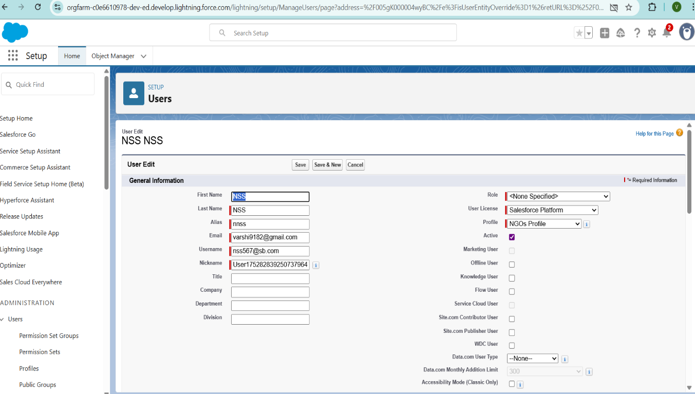

1. Give Different First Name, Last Name based on Different NGO’s.

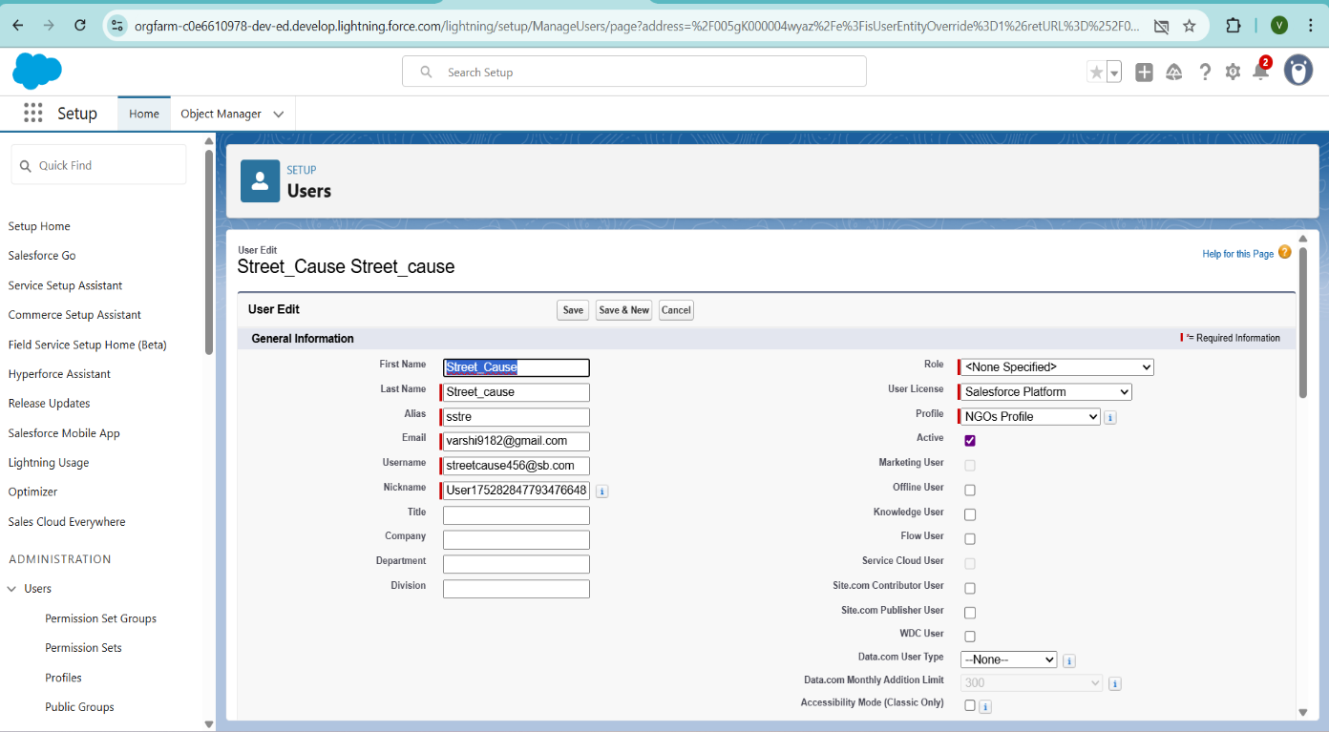

**Creation of sharing rules**

1. Go to setup >> type Sharing Settings in quick find box >> Click on the Sharing Settings.
2. Scroll down and find Drop-Off point Sharing Rules.
3. Click on new near Drop-Off point Sharing Rules and Name it as:

Label: Rule 1

Rule Name: Rule_1

1. Select your rule type: Select Based on criteria.
2. Select which records to be shared:

Field: Operator: Value = Distance: less than: 15

1. Select the users to share with: Near Share With

Public Groups: Iksha

1. Click on Save.
2. Click on new near Drop-Off point Sharing Rules and Name it as:

Label: Rule 2

Rule Name: Rule_2

1. Select your rule type: Select Based on criteria.
2. Select which records to be shared:

Field: Operator: Value = Distance: greater than: 15

Field: Operator: Value = Distance: less or equal: 30

1. Select the users to share with: Near Share With

Public Groups: NSS

1. Click on Save.
2. Click on new near Drop-Off point Sharing Rules and Name it as:

Label: Rule 3

Rule Name: Rule_3

1. Select your rule type: Select Based on criteria.
2. Select which records to be shared:

Field: Operator: Value = Distance: greater than: 30

Field: Operator: Value = Distance: less or equal: 50

1. Select the users to share with: Near Share With

Public Groups: Street Cause

1. Click on Save.

**Phase 5: Deployment, Documentation & Maintenance**

**Deployment Strategy:**

The deployment of the FOODCONNECT CRM from the sandbox environment to production was carried out using **Change Sets**, which facilitated secure and organized migration of metadata components including custom objects, fields, validation rules, flows, and Apex code. This method ensured that all dependencies were properly packaged and tested before final deployment, minimizing the risk of disruptions in the live environment.

**System Maintenance and Monitoring:**

The CRM is designed for ease of ongoing maintenance. Scheduled reports and dashboards help monitor daily operations, highlighting metrics like pending pickups and distributions completed. Regular data quality reviews are performed to identify duplicates or

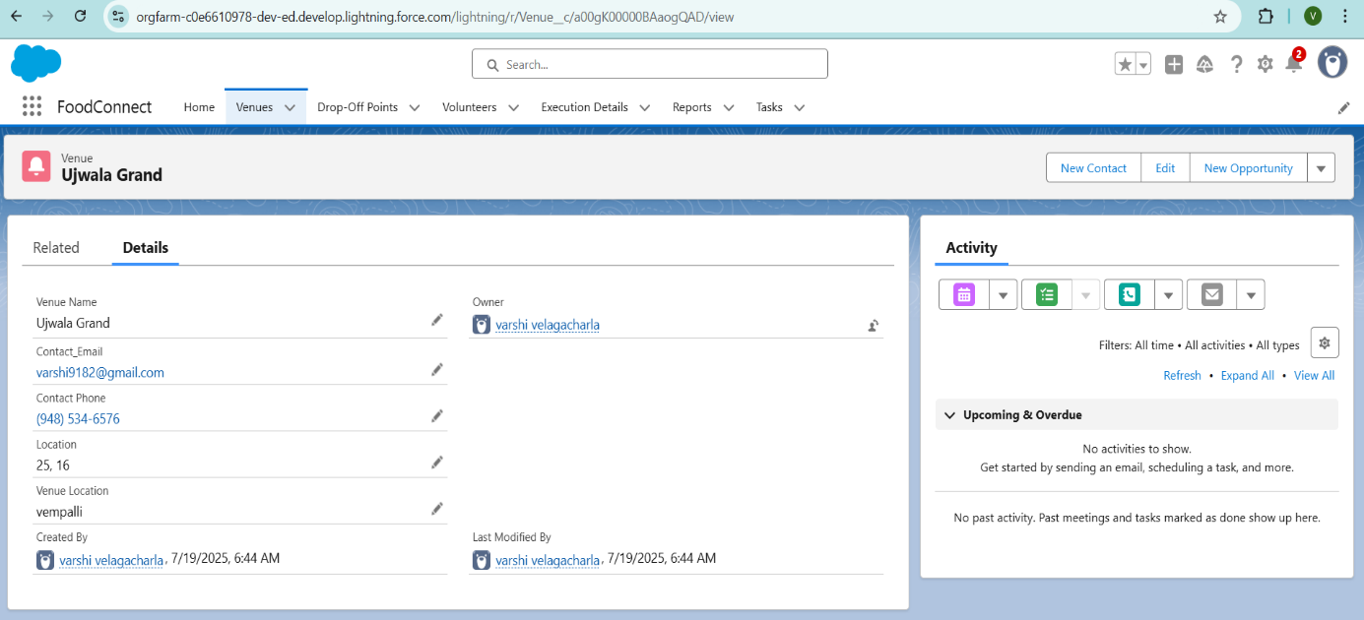

inconsistencies. Admins are responsible for periodic reviews of automation processes and ensuring that validation rules and flows continue to align with evolving business

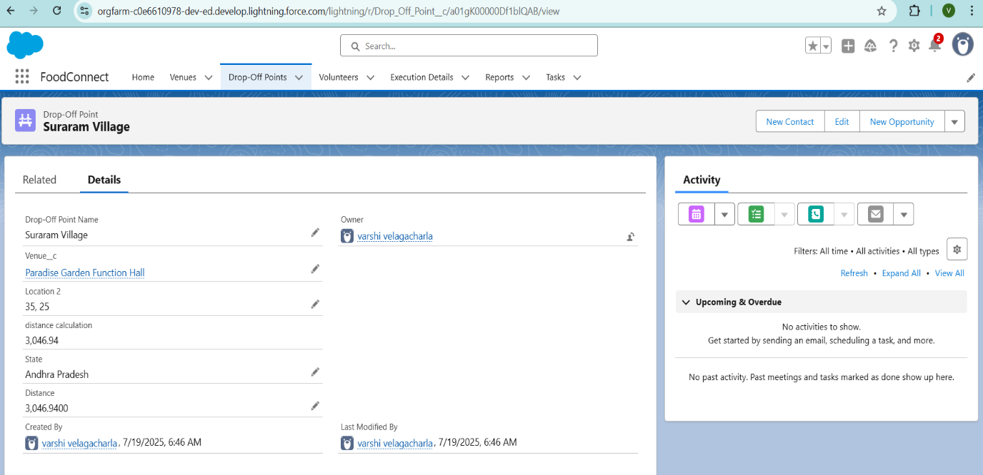

requirements. Any required enhancements or new features will be safely developed and tested in sandbox environments before being pushed to production.

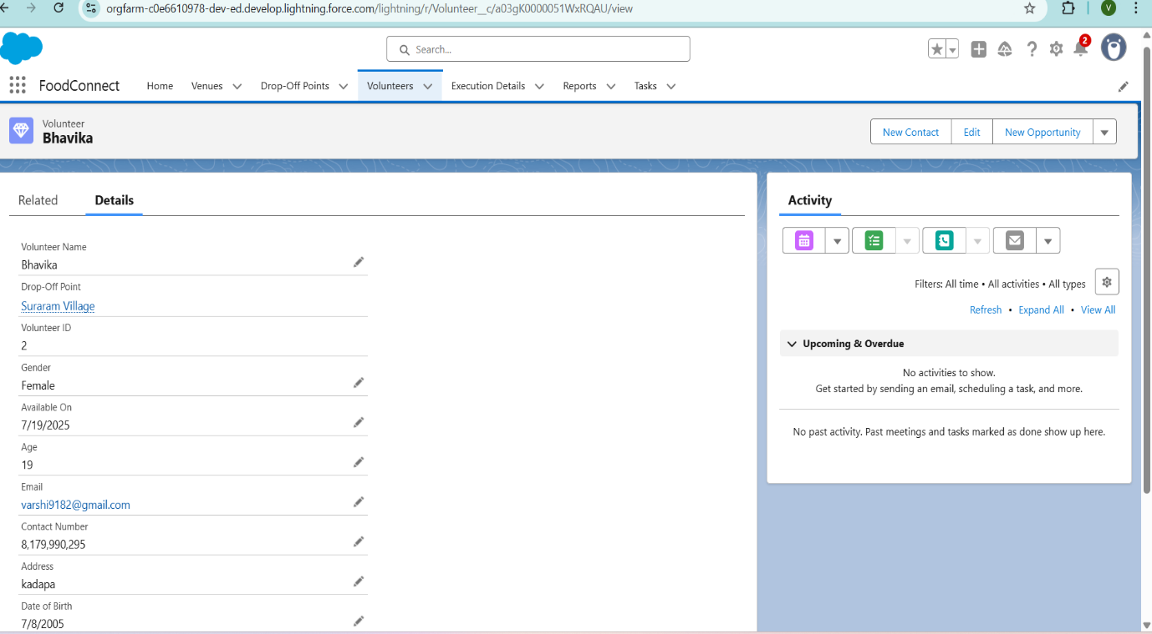

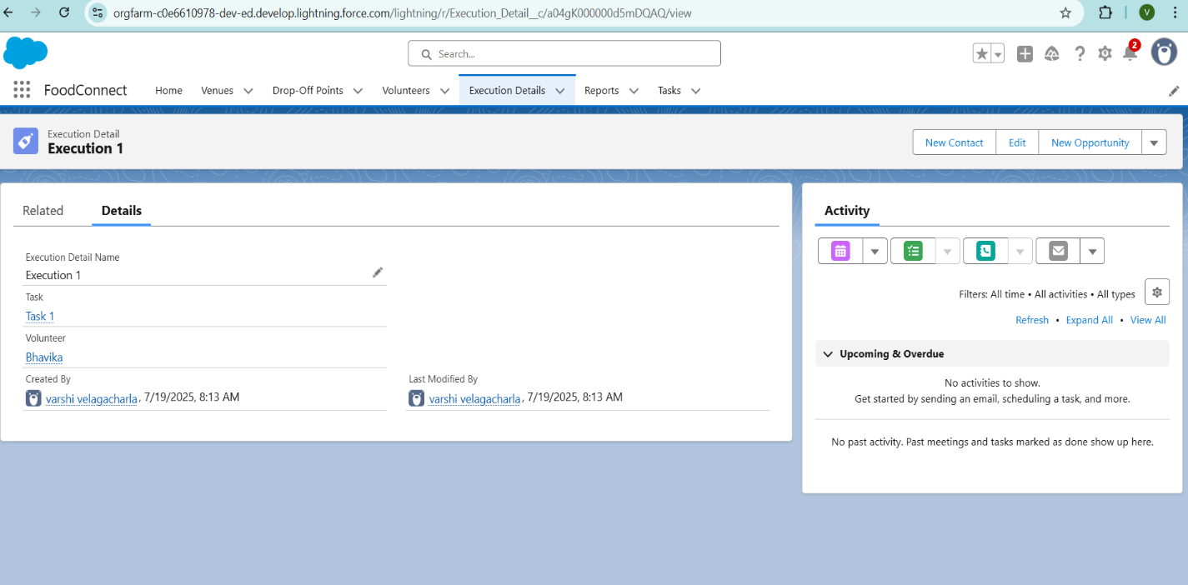

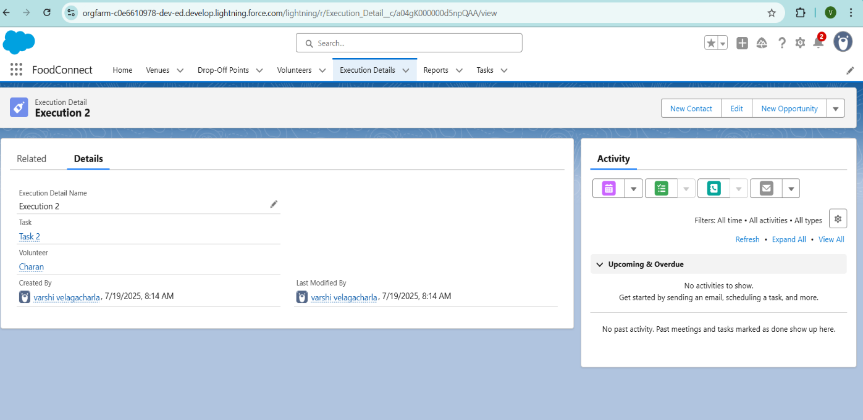

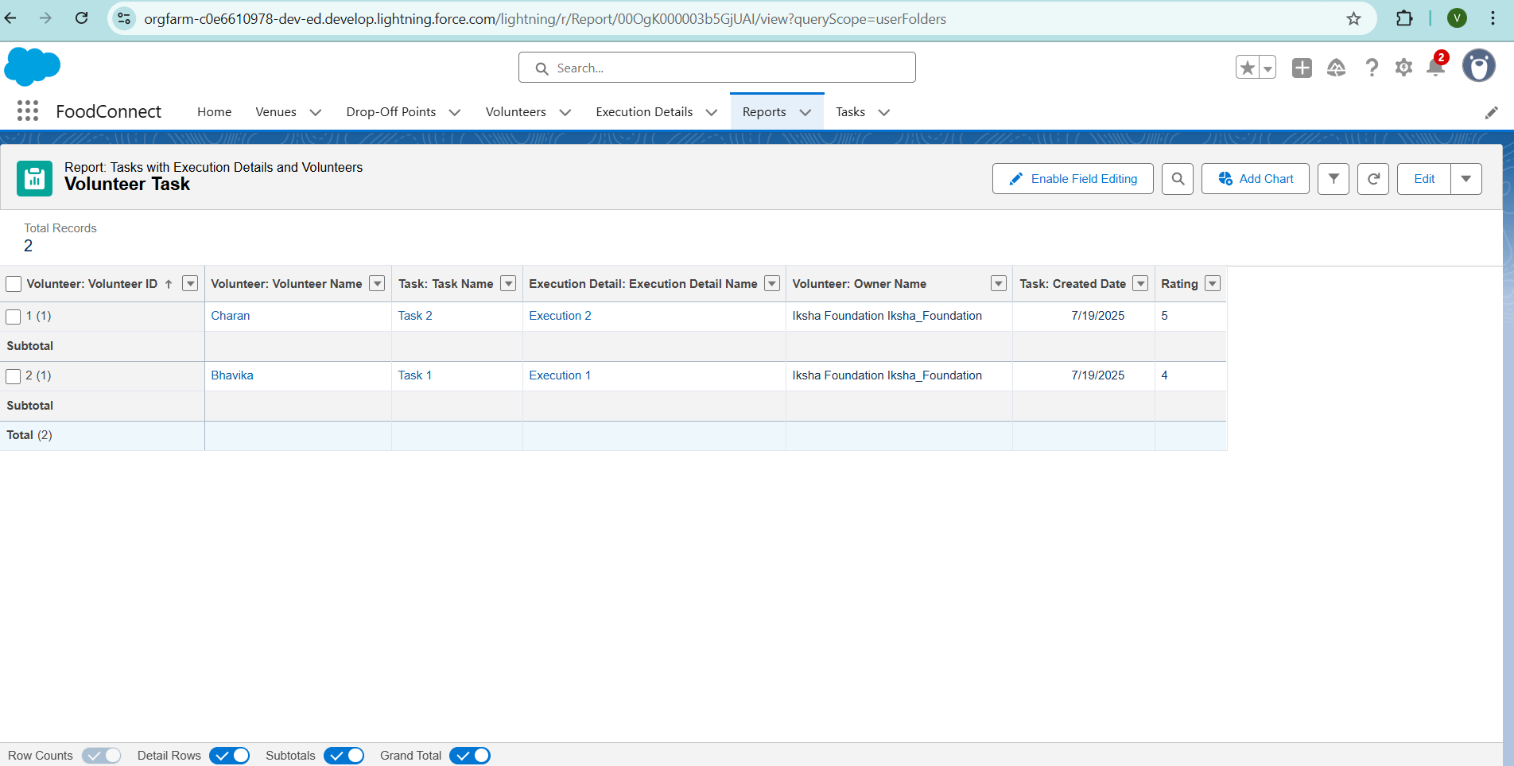

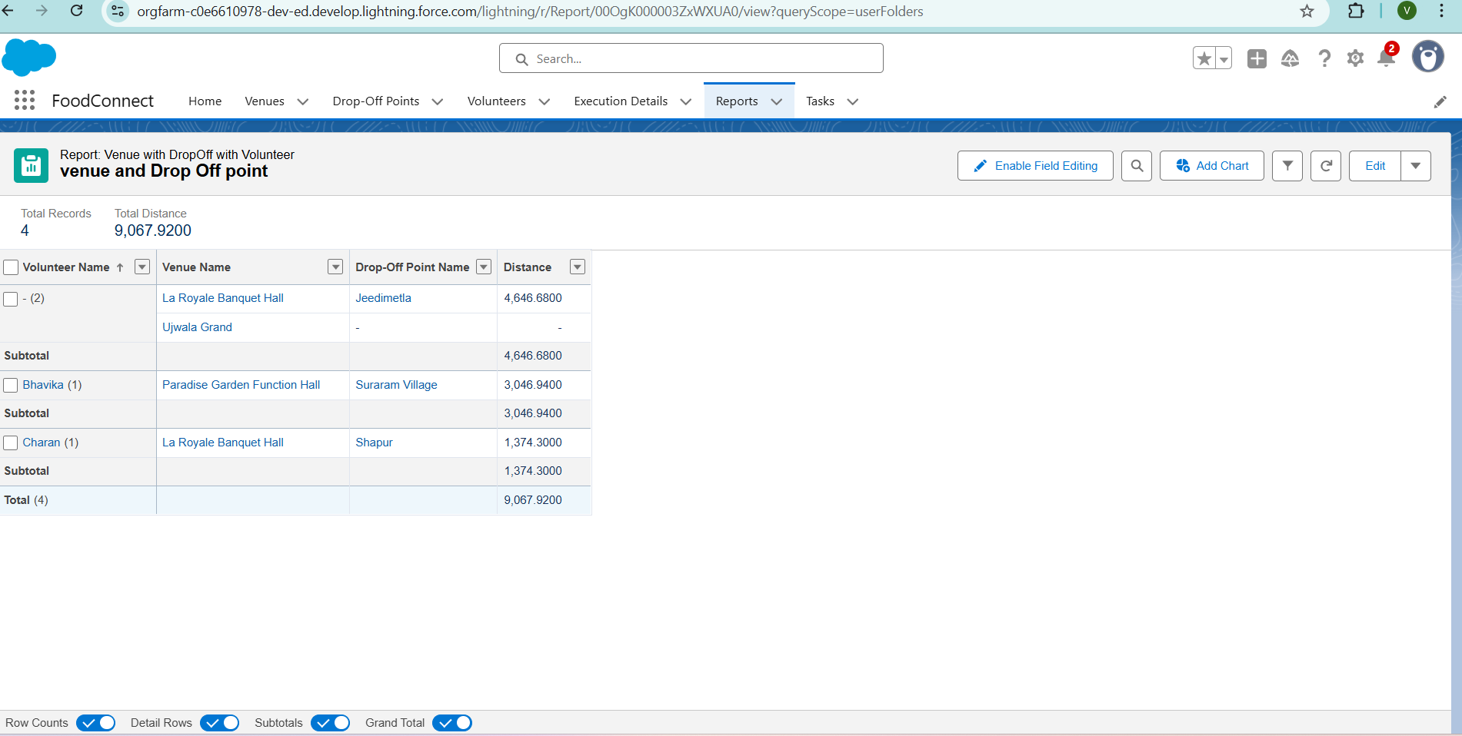

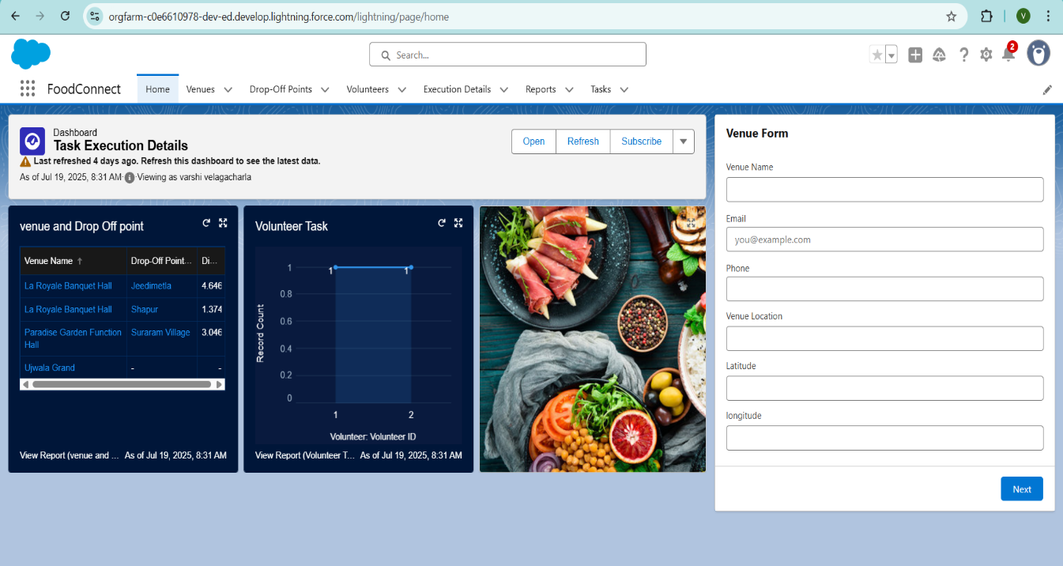

**Troubleshooting Approach:**

A systematic troubleshooting guide is maintained to resolve common issues such as failed pickups, notification errors, or data mismatches. Debug logs are reviewed to trace problems in Apex triggers or automation flows. Additionally, the CRM documentation includes details of object relationships, business logic, and error messages to assist technical teams in quickly diagnosing and fixing problems. This structured approach ensures system stability and minimizes downtime, supporting the mission of timely delivery of leftover food to the needy.

**Conclusion:**

**FOODCONNECT** demonstrates how technology can be a powerful force for social good.  
By leveraging Salesforce CRM, it automates food redistribution, reducing waste and fighting hunger.  
Real-time dashboards and communication tools improve efficiency and transparency.Its scalable design supports rapid onboarding of donors, NGOs, and volunteers.AI and chatbot integration will further optimize resource use and engagement.The platform transforms surplus into sustenance for underserved communities.It empowers nonprofits to act faster, smarter, and with greater impact.  
FOODCONNECT isn’t just a tool—it’s a mission in motion.It proves that innovation and compassion can solve real-world problems.And most importantly, it brings us closer to a world without hunger.